Group Project Documentation   
Advanced Cross-Platform Application Programming with .NET

*On Demand Tutor*

**Prepared by BCB Group**

**Nguyễn Vĩ Tiến - SE171676  
Nguyễn Xuân Đức - SE171688  
Nguyễn Văn Minh - SE172756  
Trần Vũ Khải - SE171626**

**FPT University, Ho Chi Minh City, 2024**

**Table of Contents**

**Table of Contents ii**

**Revision History ii**

**1.** **Project Introduction 1**

1.1 Product Perspective 1

1.2 User Classes and Characteristics 1

**2.** **Database Design 1**

**3.** **System Architecture 1**

**4.** **Implementation 2**

4.1. Deployment Considerations 2

4.2. Screenshots and explanations 2

**5.** **References 2**

**Revision History**

| **Name** | **Date** | **Reason For Changes** | **Version** |
| --- | --- | --- | --- |
| Nguyễn Vĩ Tiến | 18/5/2024 | Initial changes | 1.0 |
|  |  |  |  |
|  |  |  |  |
| Nguyễn Xuân Đức | 18/5/2024 | Initial changes | 1.0 |
| Nguyễn Văn Minh | 18/5/2024 | Initial changes | 1.0 |
| Trần Vũ Khải | 18/5/2024 | Initial changes | 1.0 |

# Project Introduction

## Product Perspective

The "On Demand Tutor" platform serves as a dynamic nexus, seamlessly linking students in urgent need of accessible and cost-effective educational support with seasoned tutors endowed with expertise. Catering to the diverse needs of learners, the platform welcomes recent graduates and adept individuals keen on leveraging their proficiency as tutors, contingent upon furnishing verifiable credentials.

Through the intuitive interface of the platform, students are empowered to embark on a quest for suitable tutors either by specifying their names or delving into specific subjects. This search functionality facilitates a tailored approach to finding the perfect mentor to navigate through academic challenges. Moreover, the platform fosters interactive communication channels, enabling students to engage in real-time chats with prospective tutors. Such direct interaction not only facilitates clarifying doubts but also nurtures a conducive learning environment where knowledge exchange flourishes.

Integral to the fabric of the "On Demand Tutor" platform is the feedback mechanism, wherein students can articulate their learning experiences post-sessions. This feature not only serves as a testimonial for tutors but also aids in refining the quality of educational services offered, fostering a culture of continuous improvement.

Beyond its core user base of students and tutors, the platform extends its hospitality to guests, albeit with limited access privileges. This inclusivity ensures that even those exploring the platform can glean valuable insights and potentially transition into active participants in the educational ecosystem it cultivates.

To uphold the integrity and efficacy of its operations, the platform boasts a dedicated cadre of moderators and administrators. Tasked with overseeing content and system functionalities, these guardians of quality assurance play a pivotal role in maintaining the platform's credibility and reliability.

## User Classes and Characteristics

Guest:

* View tutors
* Register as student
* Register as tutor
* View tutor’s details
* Search tutor
* Search subject

Student:

* Search tutor
* View tutors
* View tutor’s details
* Search subject
* Chat with the tutor
* Review tutor
* View registered tutor list

Tutor:

* Create tutor profile
* Upload image
* Upload certificate
* Upload self description
* View registered student list
* Upload advertisement video
* Manage student rental request

Moderator:

* Manage content
* Manage complaint

Admin:

* Manage accounts
* Manage content
* Manage complaint
* Manage system

***List of business processes:***

*Workflow 1. Tutor→ (1) Login → (3) View registered student list(will) → (4) View student’s information detail (Time, street)→ (5) Accept / Denied student when they booking → (6) Send notification to student → Check view student learning*

*Workflow 2. Member (1) Login→(2) Search service available ->(3)View detail of tutor that service -> (4) Booking tutor -> (5) View history of renting → (6) Cancel renting information (check suitable time)*

*Workflow 3. Guest (1) Register → Become a new student/tutor → (2) Login →(3)Upload certificate, Image, Video ->(4)Choose Price for service ->(5)Upload avatar account → (5) Chat with tutor/student → (6) Rent tutor*

*Workflow 4: Tutors → (1) Register → (2) A moderator reviews and approves the tutor's profile → (3) Tutors create and set up their tutoring services → (4) Tutors conduct the tutoring sessions as per the scheduled appointments → (7) Tutors monitor students' progress and offer support when necessary → (8) Students provide feedback or report service after learning.*

*Workflow 5. Admin(1) Login→ (2) View list accounts →(3)Choose account want to delete →(4) Accept→ (5)Send successfully notification -> (6) Record deletion action by Admin.*

***Business Rule:***

| ID | Business rules | Description |
| --- | --- | --- |
| BR01 | Limited Access for Guests | Guests should have limited access to system features. |
| BR02 | Create Services | Tutors can create services by the hour options for students. |
| BR03 | Rating Restriction | Students must rent a tutor before being able to rate them. |
| BR04 | Rental Hours Entry | Students must enter the number of needed rental hours. |
| BR05 | Tutor Credentials | Tutors must upload their certificates and credentials when registering their profile. |
| BR06 | Admin Approval for Tutor Changes | Admin must approve any changes made by tutors to rental prices, descriptions, or credentials. |
| BR07 | Price Currency and Rules | Prices must be in VND currency, and must increase or decrease based on hours; prices cannot be negative. |
| BR08 | Tutor’s Booking Availability | Tutors must regularly update their availability to ensure accurate scheduling by students. |
| BR09 | Service Time Availability | Student can only book free-time of the service. |
| BR10 | Moderator Management | Moderator accounts are created and change password only by admin. |
| BR11 | Tutor Availability | Tutor can only access full features if they are approved by moderator. |
| BR12 | Password Modification | Students and Tutors can reset their password by receiving a reset link through email. |

# Database Design

* ERD DIAGRAM

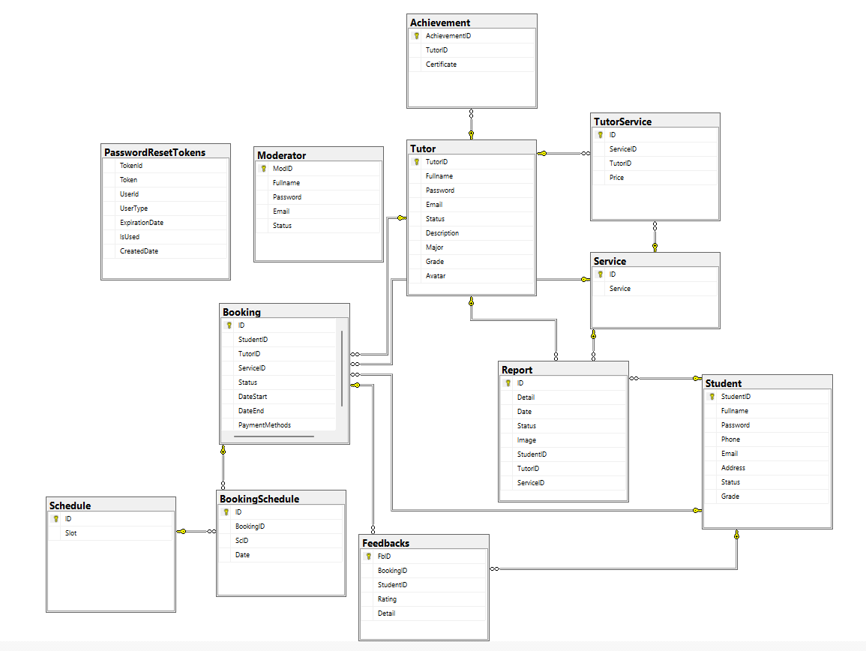

# System Architecture

### **Environment Description**

#### Hardware Platform

The project will operate on standard server hardware suitable for web applications.

#### Operating Systems and Versions

* **Server**: The server will run on a Linux or Windows-based operating system.
* **Client Machines**: Users will access the application through web browsers on various operating systems (Windows, macOS, Linux).

### **System Architecture**

#### Project Structure

* **BusinessObjects**: Contains the domain models and entities used across the application.
* **OnDemandTutorRazorPage**: The main project containing Razor Pages for the user interface.
* **DataAccessLayer**: Retrieve data and communicate with the database.
* **Repositories**: Handles data access and communication with the DataAccessLayer.
* **Services**: Contains business logic and service layer interacting with repositories and external services.

### **Detailed Description**

#### Razor Pages (Presentation Layer)

* The user interface is built using .NET 8 Razor Pages, allowing guests, students, tutors, moderators, and admins to interact with the system.
* Razor Pages handle user input and present data fetched from the service layer.

#### Services (Business Logic)

* This layer contains the core business logic of the application.
* It processes requests from the Razor Pages, interacts with the repository layer, and communicates with external services for image storage.

**Repository Layer**

* This layer acts as an intermediary between the Data Access Layer and the higher-level business logic.
* It provides a layer for the service layer to perform CRUD (Create, Read, Update, Delete) operations including business logic.
* Each entity typically has its own repository (e.g., AccountRepository, TutorRepository, BookingRepository).
* The Repository Layer calls methods from the DAL to interact with the database.
* It may include additional business logic or data manipulation before passing data to or from the DAL.

**Data Access Layer (DAL)**

* This layer directly interacts with the database using ORM like Entity Framework.
* It contains classes that represent database entities (e.g., User, Tutor, Booking).
* The DAL includes methods for executing SQL queries, stored procedures, and handling database connections.
* It's responsible for mapping database results to entity objects.

**Database Layer**

* Microsoft SQL Server is used as the database management system.
* SQL Server Management Studio (SSMS) is utilized for database administration and query execution.
* The database stores all application data, including user information, tutor details, booking records, etc.
* Tables, stored procedures, and views are created and managed using SSMS.

#### External Services

* **Firebase**: An external service used for storing and managing images and media files. It offers scalable and efficient media storage solutions.

### **New Technologies**

#### Firebase

* Firebase offers advanced media management capabilities, including image transformation, optimization, and responsive delivery.

# 4. Implementation

## 4.1 Deployment Considerations

### **Security**

* **HTTPS**: Use HTTPS to encrypt data transmitted between the client and server.
* **Role-Based Access Control (RBAC)**: Implement RBAC to ensure users have appropriate permissions.
* **Regular Updates**: Regularly update dependencies and perform security audits to identify and mitigate vulnerabilities.

### **Performance**

* **Database Optimization**: Optimize database queries to reduce latency.
* **Caching**: Use caching strategies to store frequently accessed data and reduce database load.
* **Asynchronous Processing**: Implement asynchronous processing for long-running tasks to improve responsiveness.

## User Access Requirements

### **Students**

* **Registration**: Students must register with a valid email address and create a password.
* **Profile Creation**: Students create profiles with personal details and academic preferences.
* **Search and Booking**: Students must have access to search for tutors and book sessions based on their availability.
* **Feedback and Rating Submission**: Students should be able to provide feedback after sessions.
* **Payment**: Student can use payment gateway to pay booking fee to tutor

### **Tutors**

* **Registration**: Tutors must register and provide verifiable credentials.
* **Profile Management**: Tutors need access to create and manage their profiles, including uploading certificates and media.
* **Session Management**: Tutors must be able to view booking requests, accept or deny them, and manage their schedules.
* **Student Monitoring**: Tutors need tools to monitor student progress and provide additional support.
* **Feedback Review**: Tutors should have access to feedback left by students.

### **Administrators**

* **Account Management**: Administrators must be able to view, manage, and delete user accounts.
* **Dashboard Overview**: Administrators can oversee system statistics and ensure it adheres to platform standards.
* **System Monitoring**: Administrators require access to monitoring tools to track system performance and health.

## Training and Business Process Modifications

### **Training**

* **User Documentation**: Provide comprehensive user manuals and online documentation to help users navigate the platform.
* **Tutorials and Demos**: Offer video tutorials and live demos to demonstrate key functionalities.
* **Support Channels**: Establish support channels such as chat support, email support, and a helpdesk for user queries and issues.

### **Business Process Modifications**

* **Integration of New Tools**: Introduce new tools and workflows for managing user registrations, booking systems, and real-time communication.
* **Feedback Mechanism**: Implement a feedback mechanism to gather user input and continuously improve the platform.
* **Regular Training Sessions**: Conduct regular training sessions for tutors and administrators to familiarize them with platform updates and new features.
* **Quality Assurance**: Establish a dedicated quality assurance team to oversee content and ensure the platform maintains high standards of educational support.

## 4.2 Screenshots and explanations

### 4.2.1 <Screen flow | Dialog Map>

*Workflow 1. Tutor→ (1) Login → (2) View registered student list(will) → (3) View student’s information detail (Time, street)→ (4) Accept / Denied student when they booking → (5) Send notification to student → (6)Check view student learning ->(7) Check done after teaching finish*

(1)Login

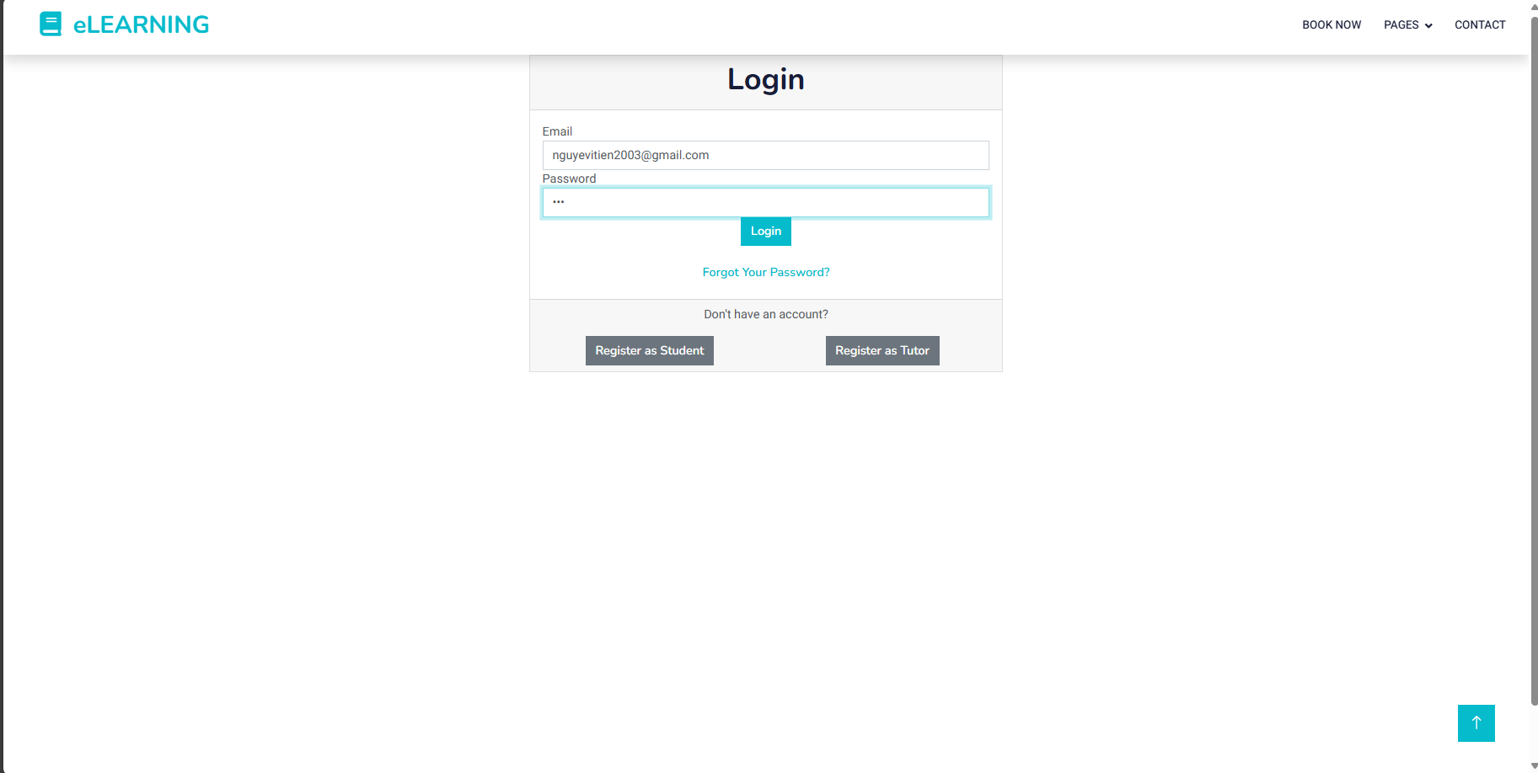

(2) View registered student

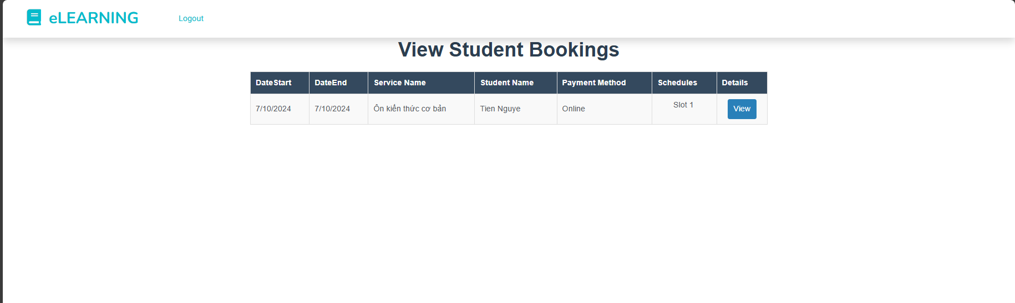

(3)View student’s information detail

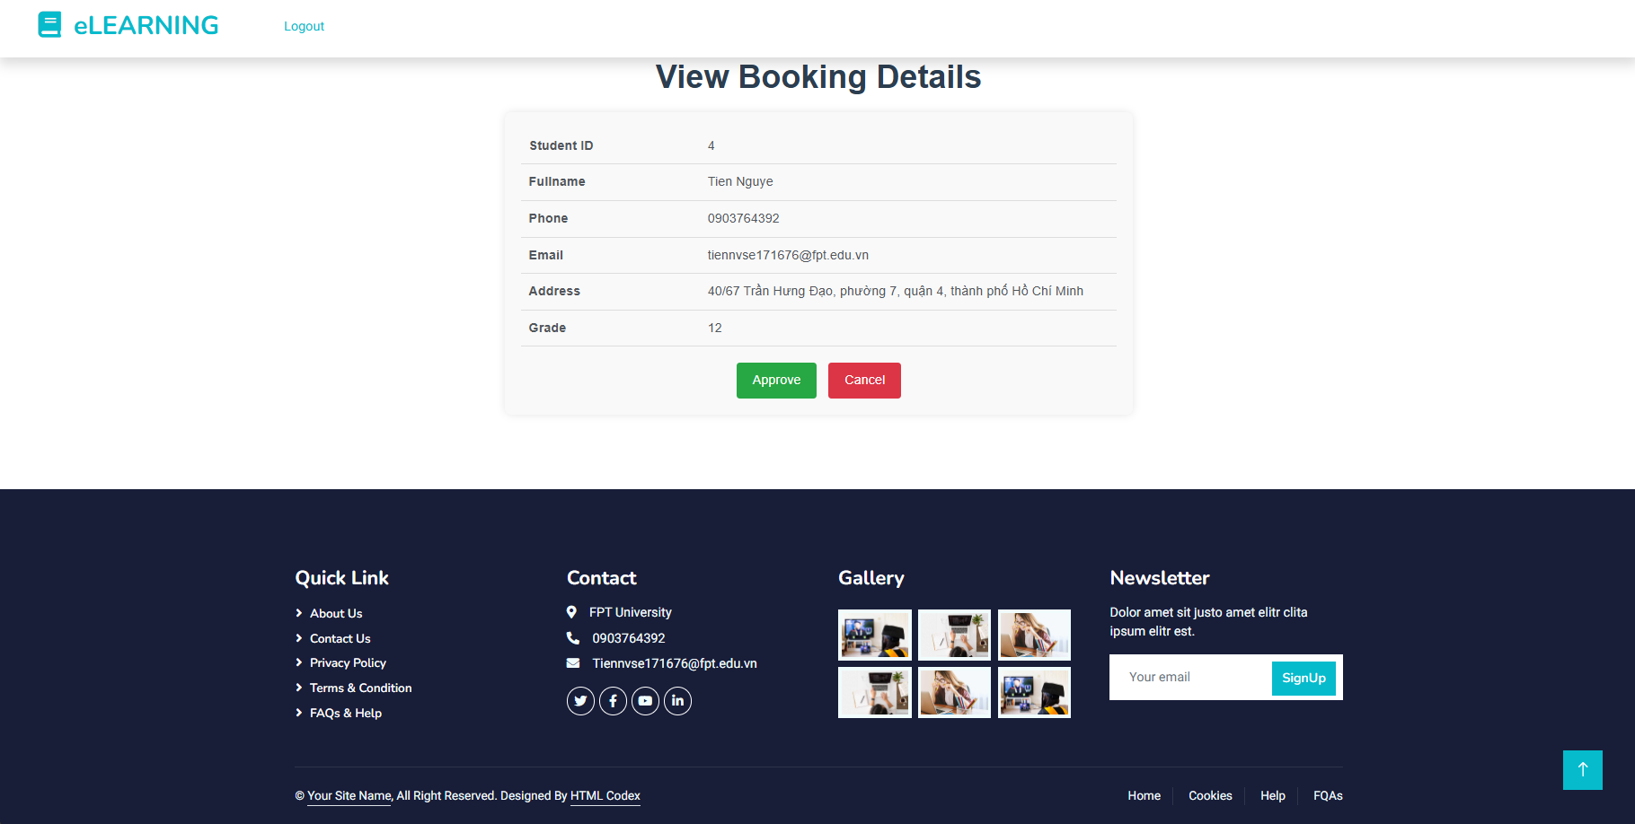

(4) Accept/deny student booking

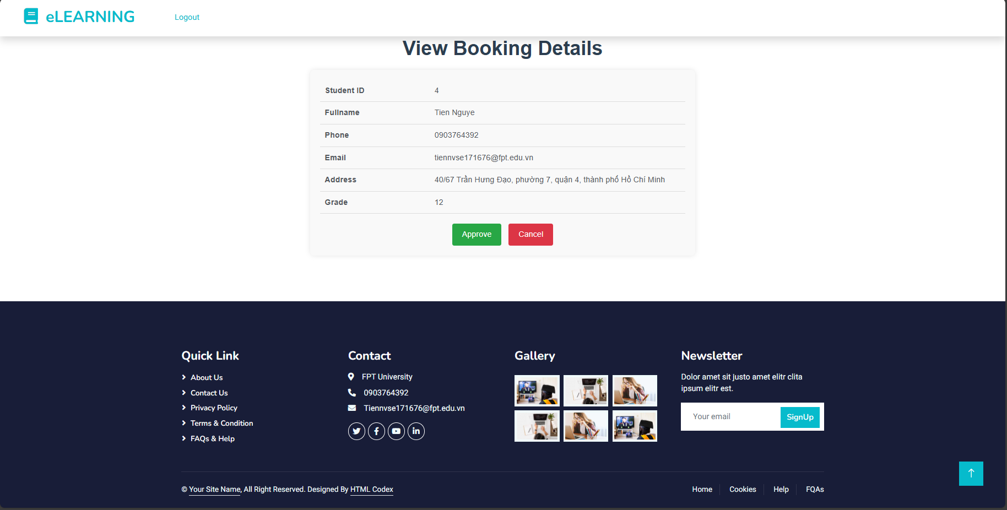

(6)Check view student learning

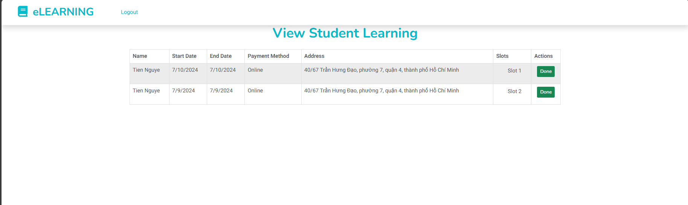

(7)Check done after teaching finish

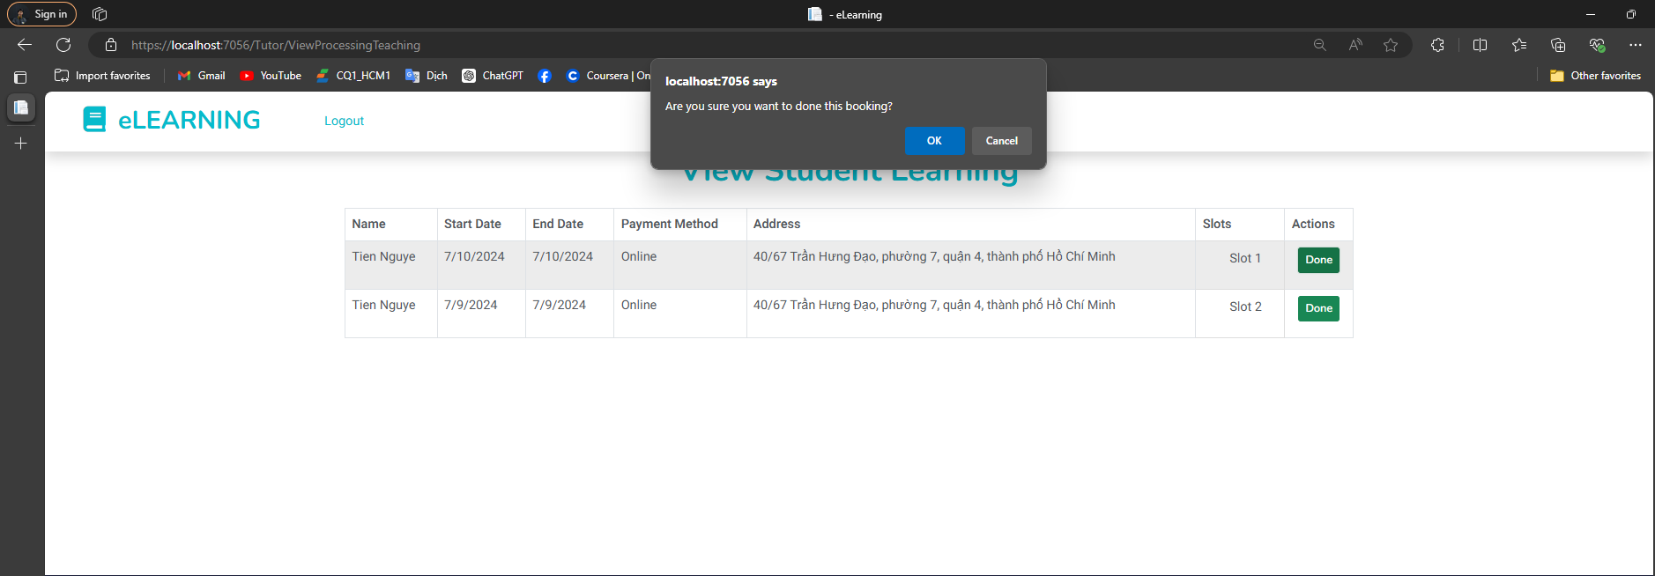

*Workflow 2. Member (1) Login→(2) Search service available ->(3)View detail of tutor that service -> (4) Booking tutor -> (5) View history of renting → (6) Cancel renting information (check suitable time)*

(1)Login 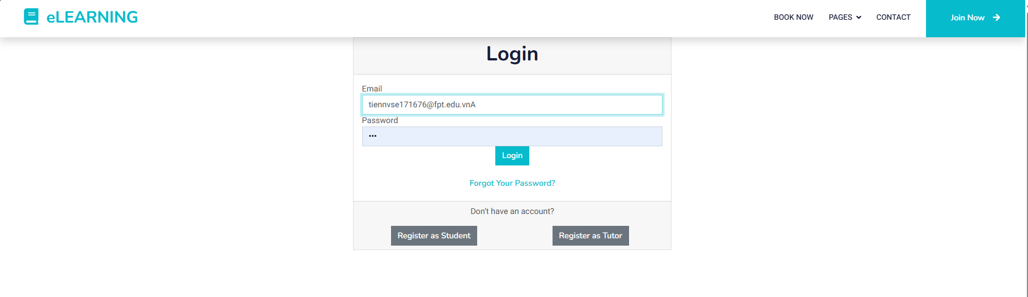

(2) Search service available

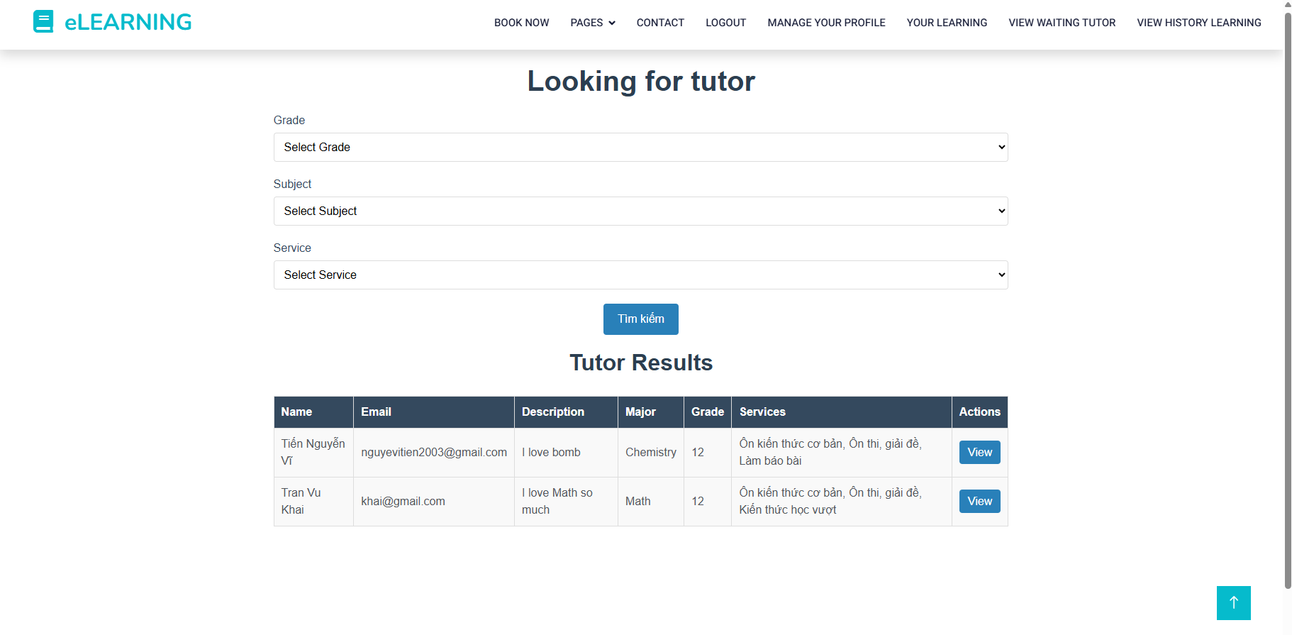

(3) View detail of tutor information

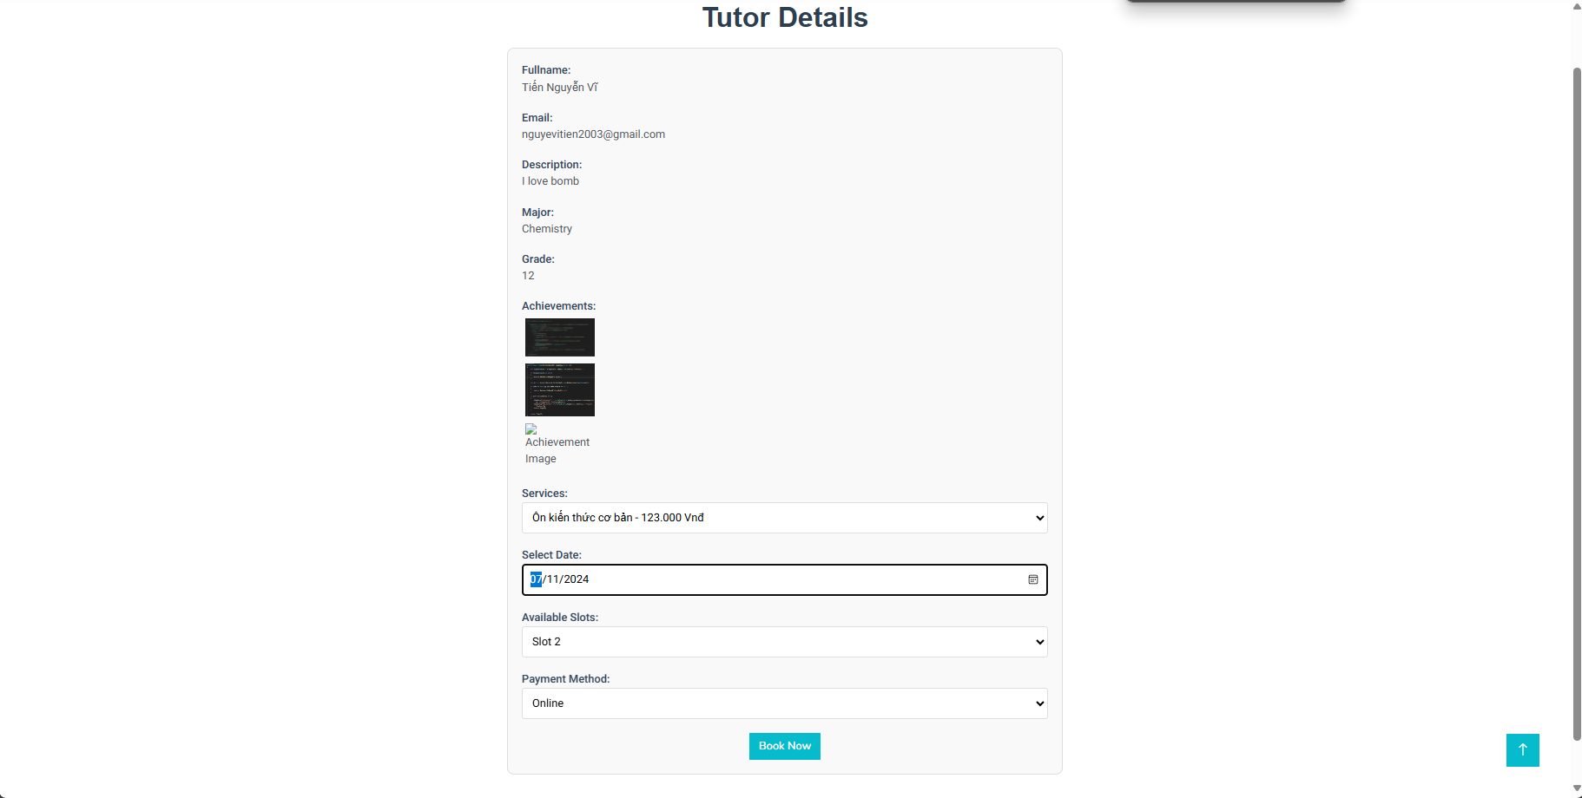

(4)Booking service



(5) View history of renting

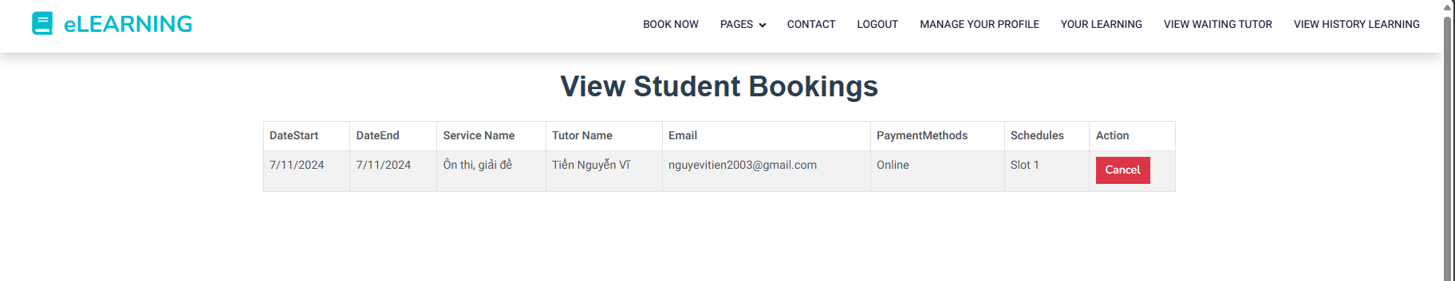

(6)Cancel renting information (check suitable time)

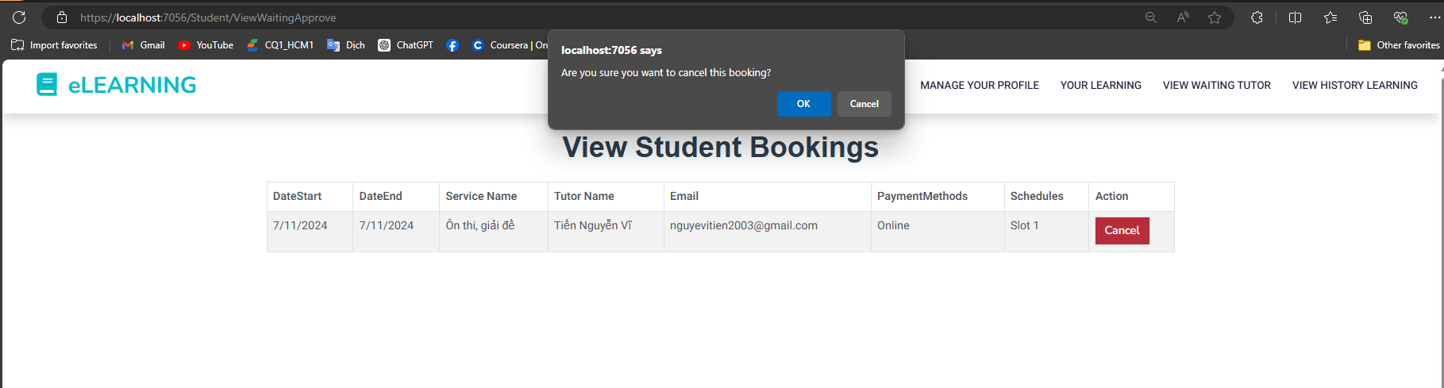

*Workflow 3. Guest (1) Register → Become a new student/tutor → (2) Login →(3)Upload certificate, Image, Video ->(4)Choose Price for service ->(5)Upload avatar account → (6) Chat with tutor/student → (7) Rent tutor*

(1) Register Tutor

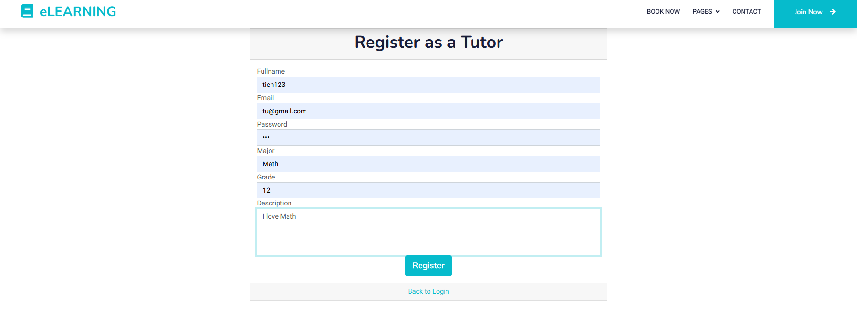

(2) Login



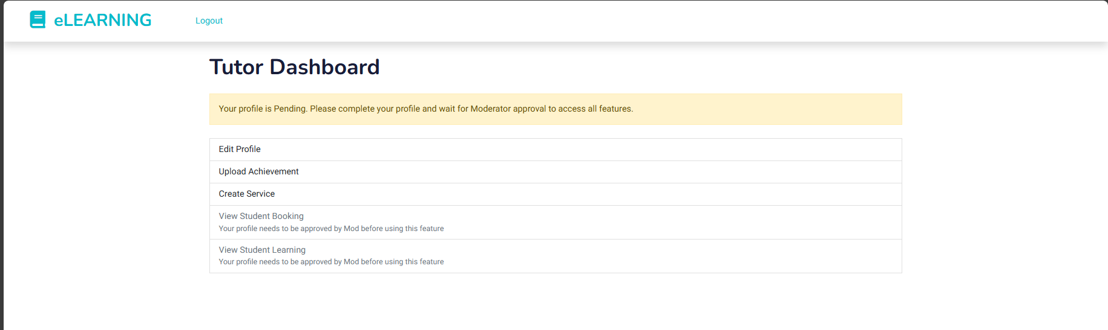

(3)Upload achievement



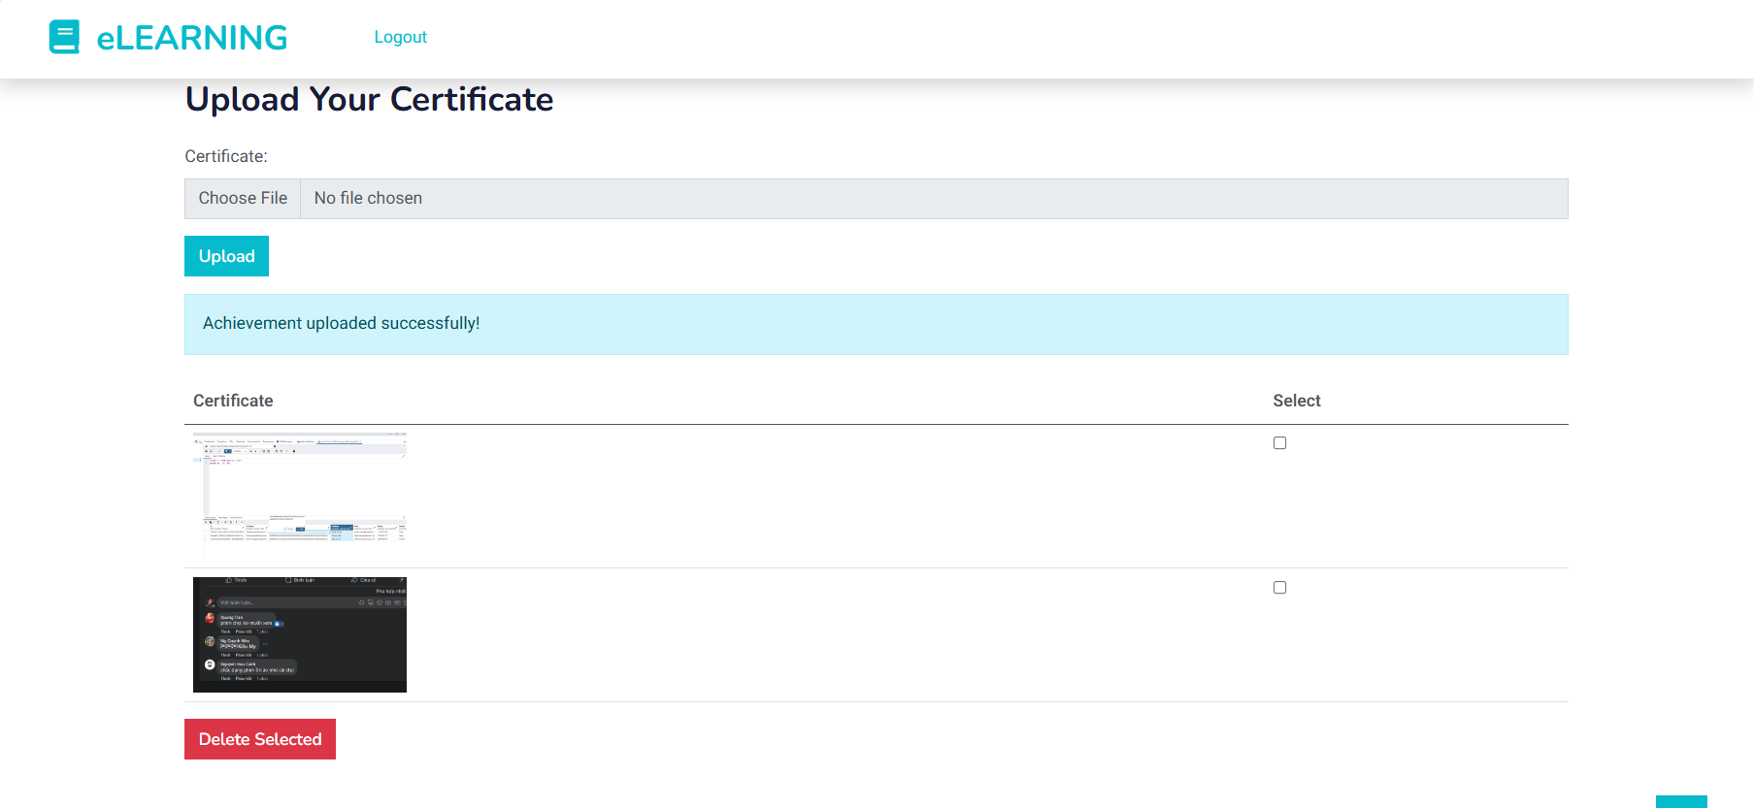

(4)Choose price for service

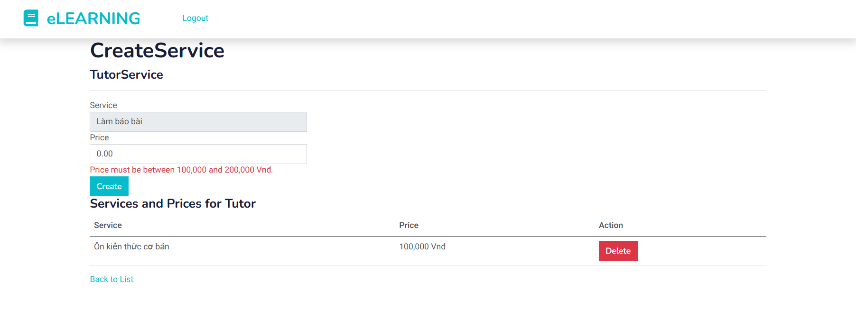

(5)Upload avatar account

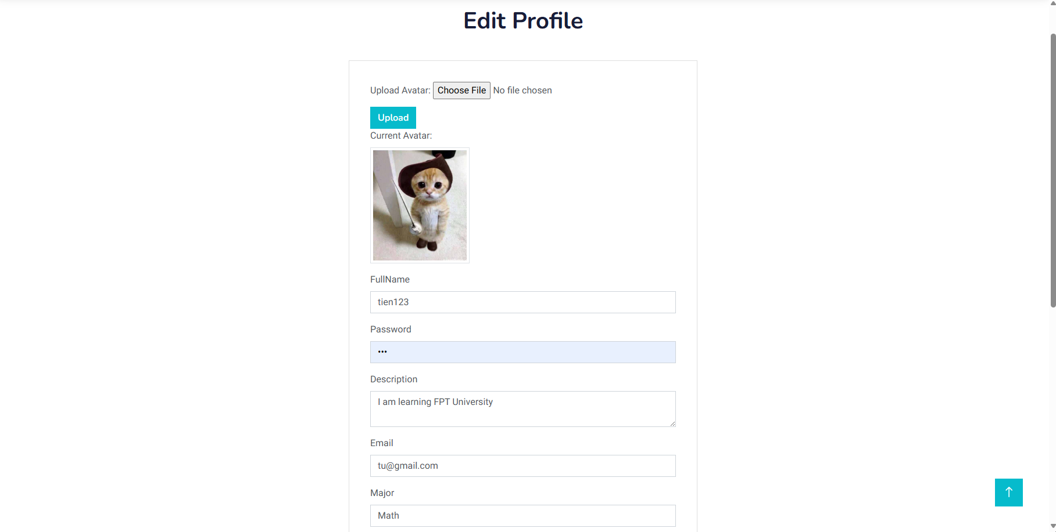

(6)Waiting for accepting by moderator

*Workflow 4: Member (1) Login→ (2) A moderator reviews ->(3) Approves the tutor's profile → (4) Tutors conduct the tutoring sessions as per the scheduled appointments → (5) Tutors monitor students' progress and offer support when necessary → (6) Students provide feedback or report service after learning.*

(1)Login

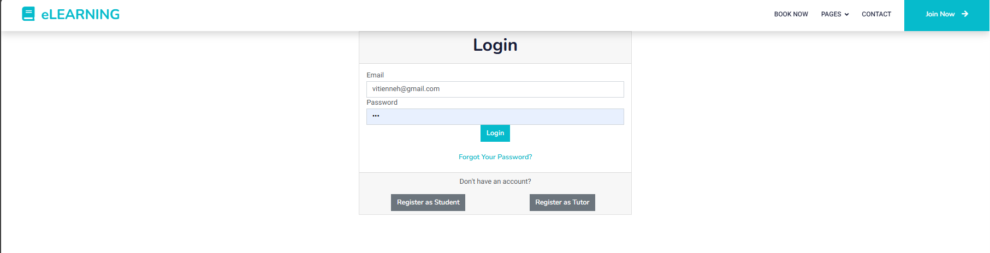

(2) Moderator review

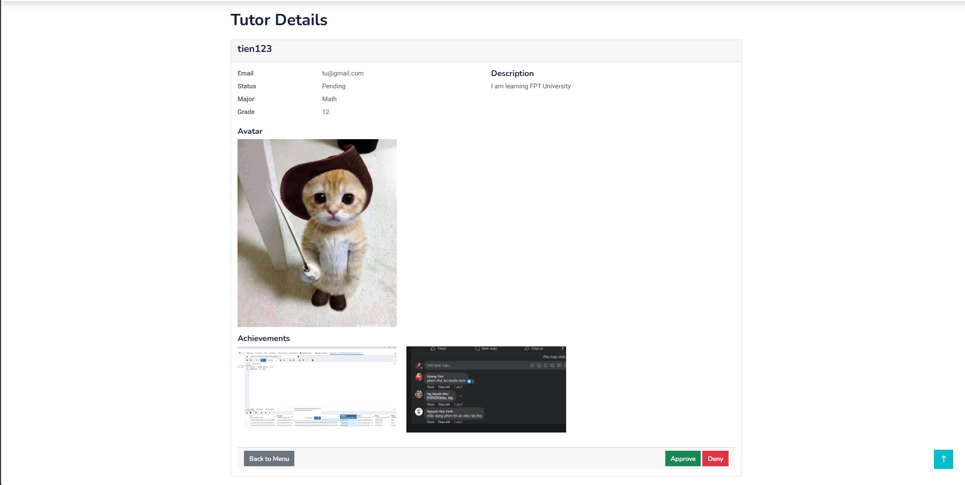

(3)Approve tutor’s profile



(4)Tutors conduct the tutoring sessions as per the scheduled appointments

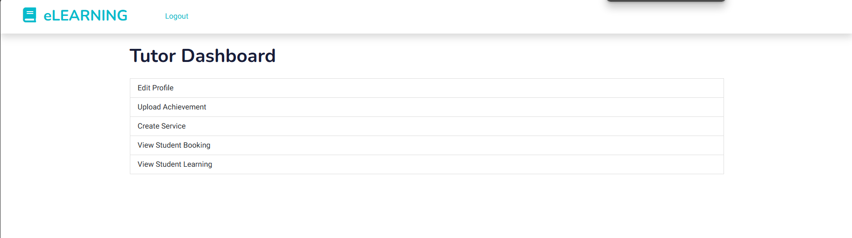

(5)Tutors monitor students' progress and offer support when necessary

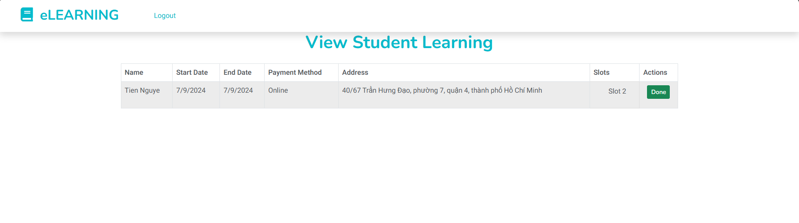

(6) Students provide feedback or report service after learning.

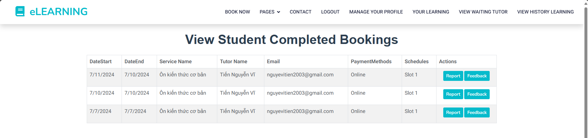

FeedBack:

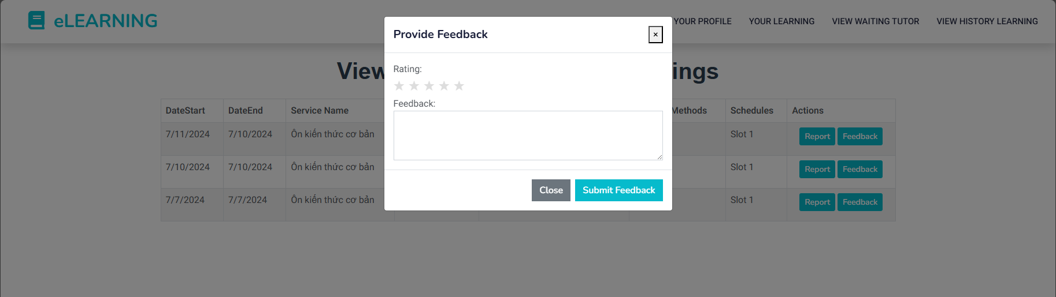

Report:

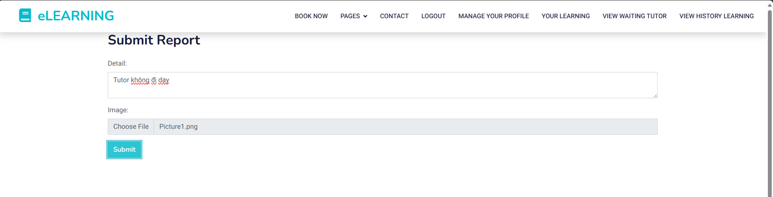

*Workflow 5. Admin(1) Login→ (2) View list accounts →(3)Choose account want to delete →(4) Accept→ (5)Send successfully notification -> (6) Record deletion action by Admin.*

(1)Login

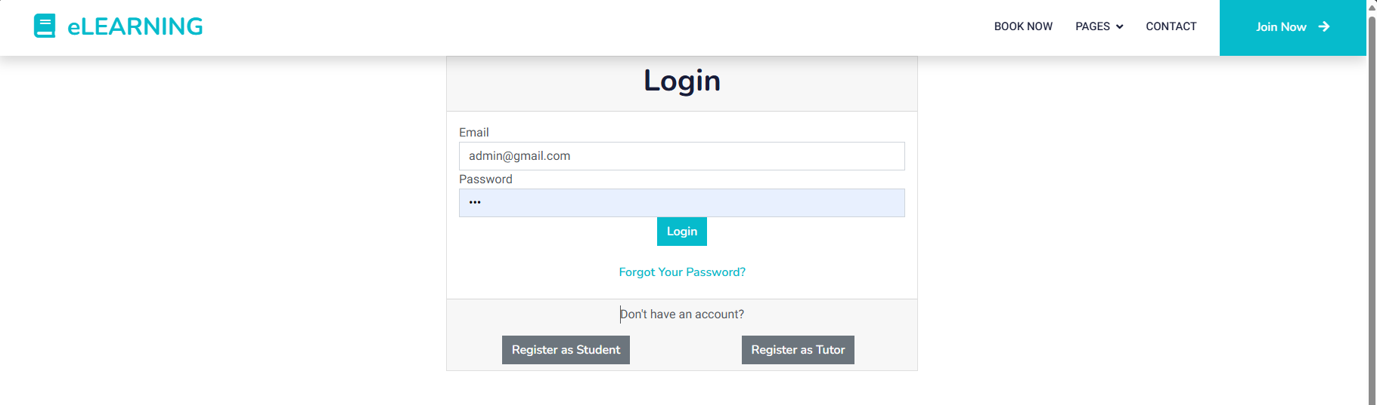

(2)View list account

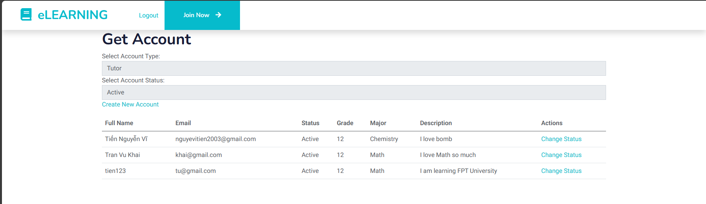

(3)Choose account want to delete

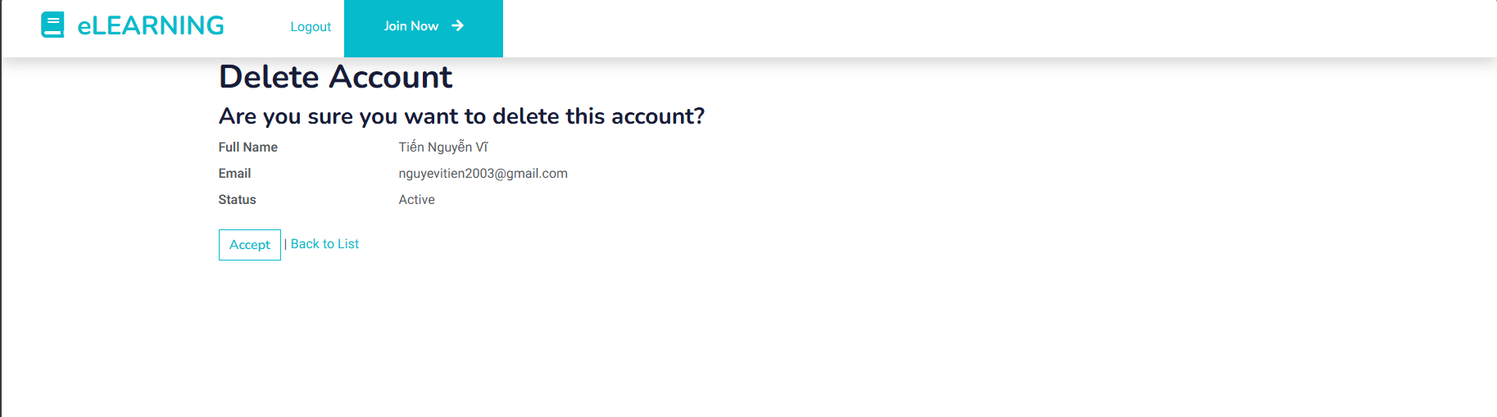

(4)Accept



(6) Record deletion action by Admin.

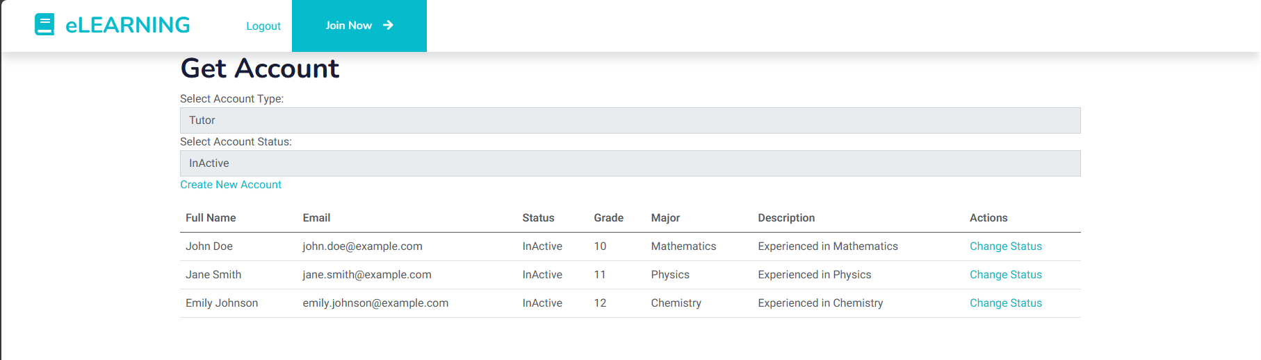

### 4.2.2 <The screenshots and explanations>

4.2.2.1: Homepage

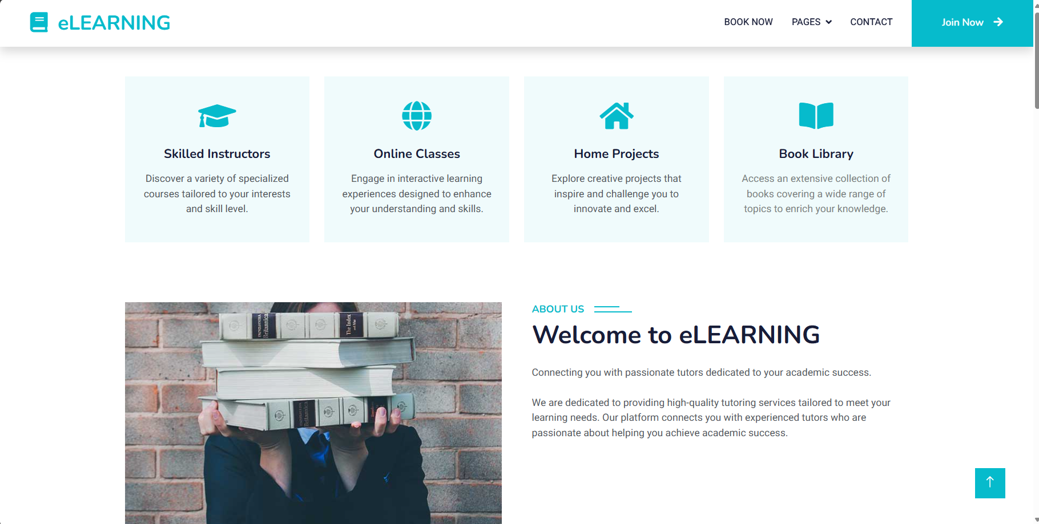

- The screen is for all guests when they first-time access the website

- Guests can choose to view tutor, feedback, or login into the system for using more features.

4.2.2.2 Register by student

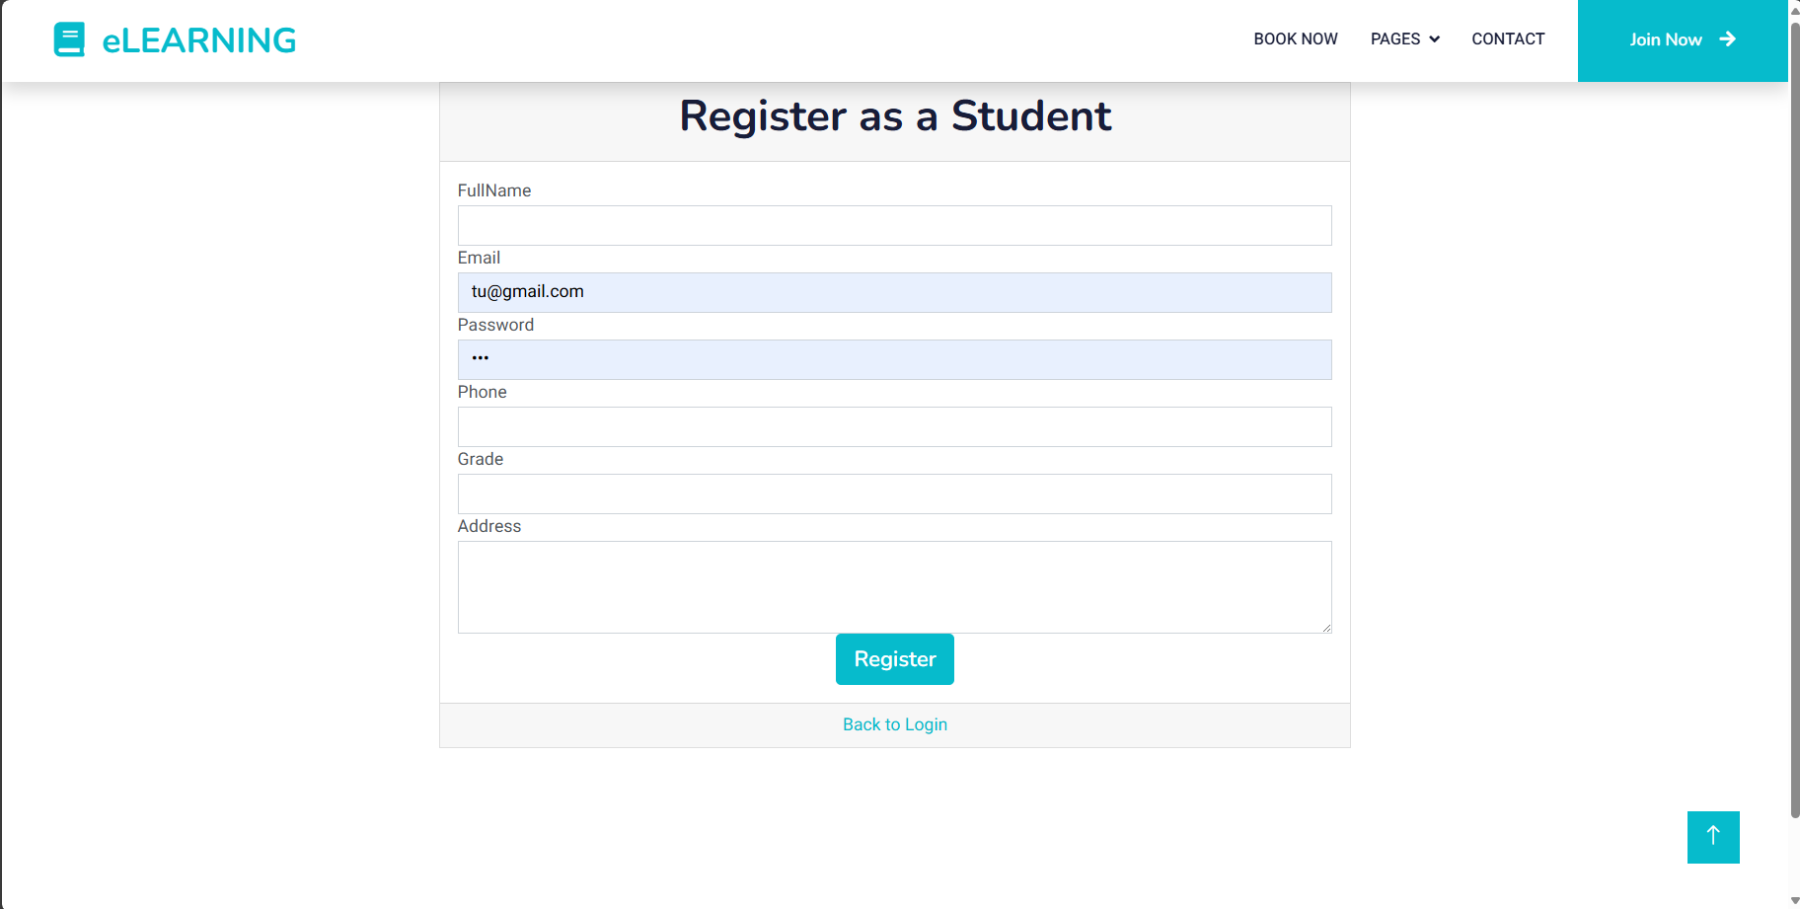

- This screen is for guests who would like to register to become a student for using more features including requirements:

* Full name field : required, cannot contain numbers or special characters
* Email field: required, valid email format
* Password field: required
* Grade field: required
* Address field: required

4.2.2.3: Register by tutor

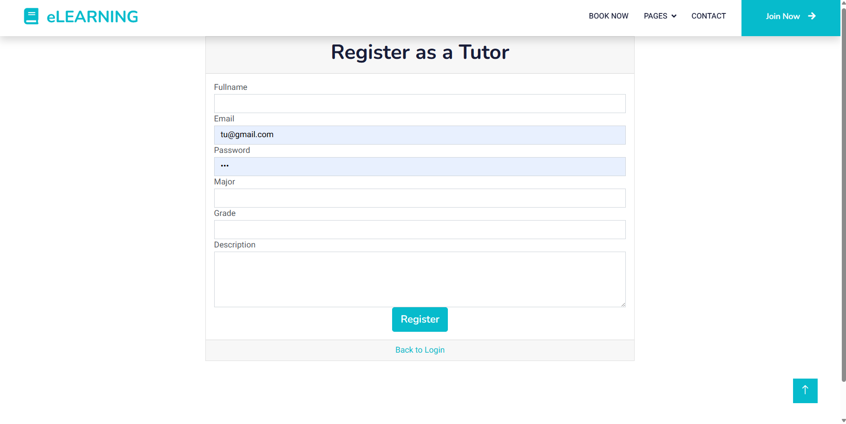

- This screen is for guests who would like to register to become a tutor for using more features including requirements:

* Full name field : required, cannot contain numbers or special characters
* Email field: required, valid email format
* Password field: required
* Major: required
* Grade field: required
* Description field: required

**STUDENT:**

4.2.2.4: Service booking tutor

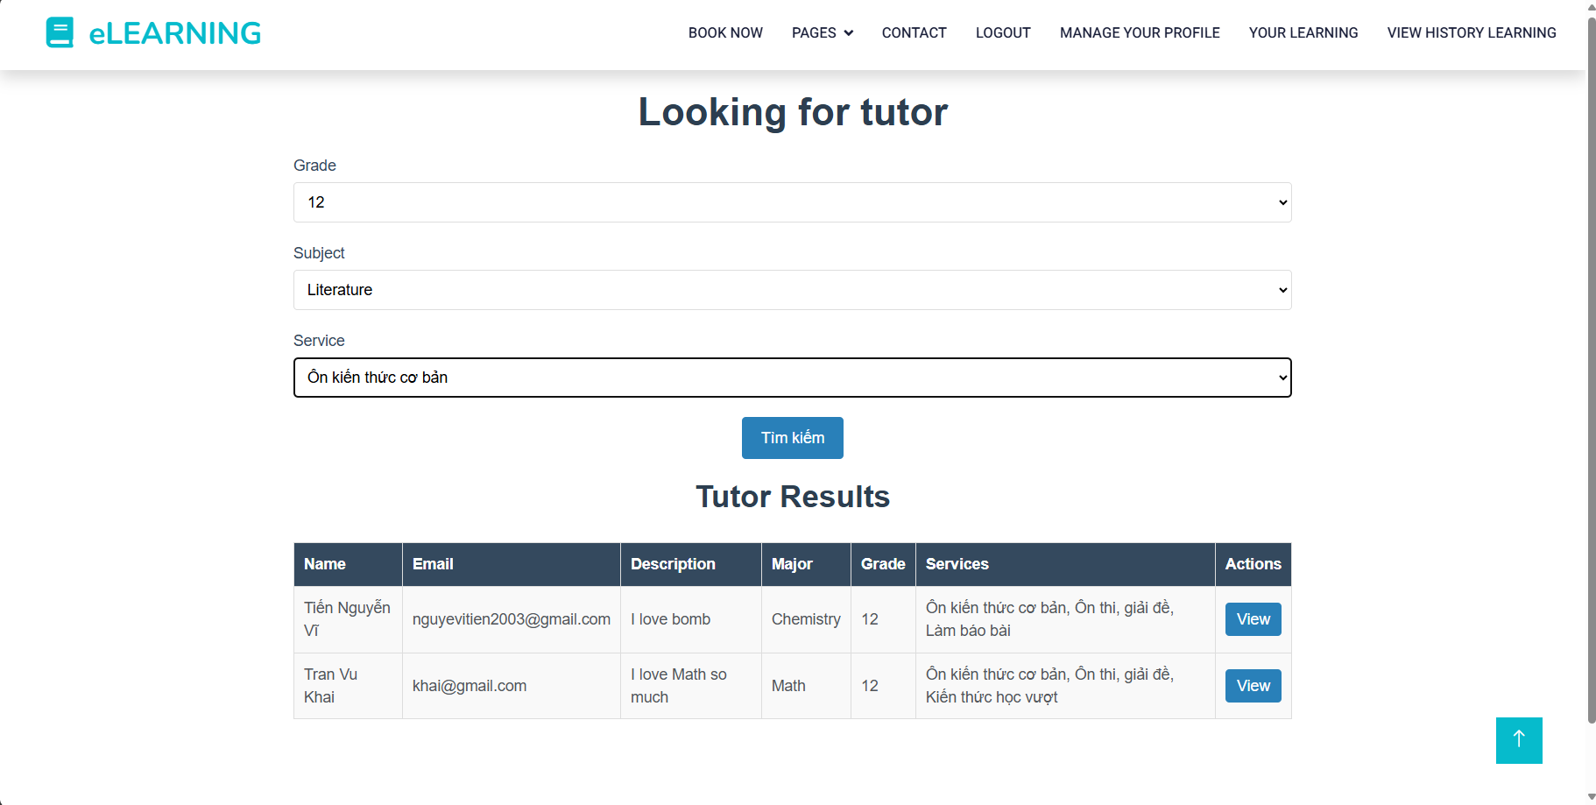

- The screen for all student to view available services of the website.

- Students can choose to view details of a Tutor by clicking the “View” button.

4.2.2.5 View detail tutor

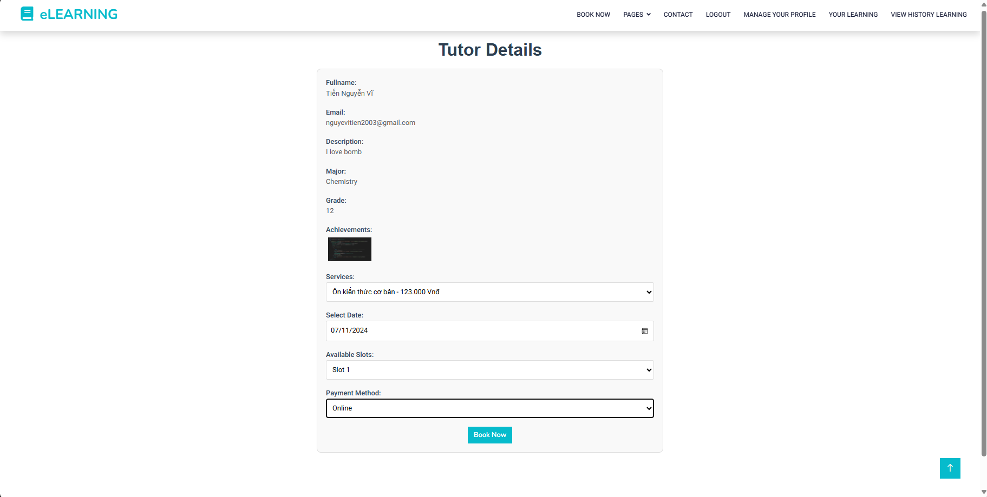

- The screen for students to view details of tutor services on the website.

- Students can choose available services with the price next to, choose date for learning, choose slot, and Payment methods: online and offline.

- Students must wait for the tutor to accept your booking.

4.2.2.6: View waiting approve

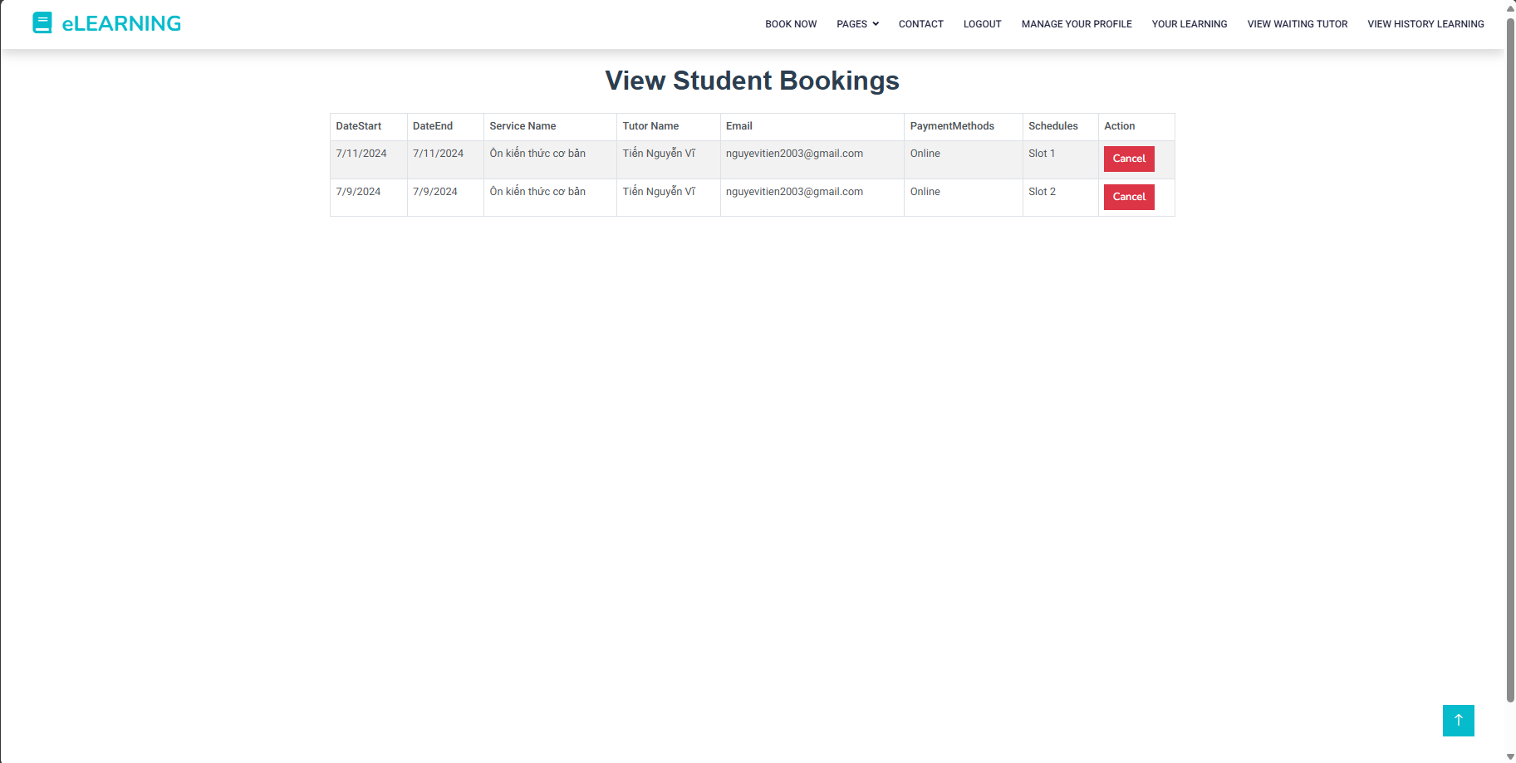

- The screen for students to view details your service that you booked tutor

- Students can choose the “Cancel” when they don’t want to learn or change other slots, service.

4.2.2.7: View learning

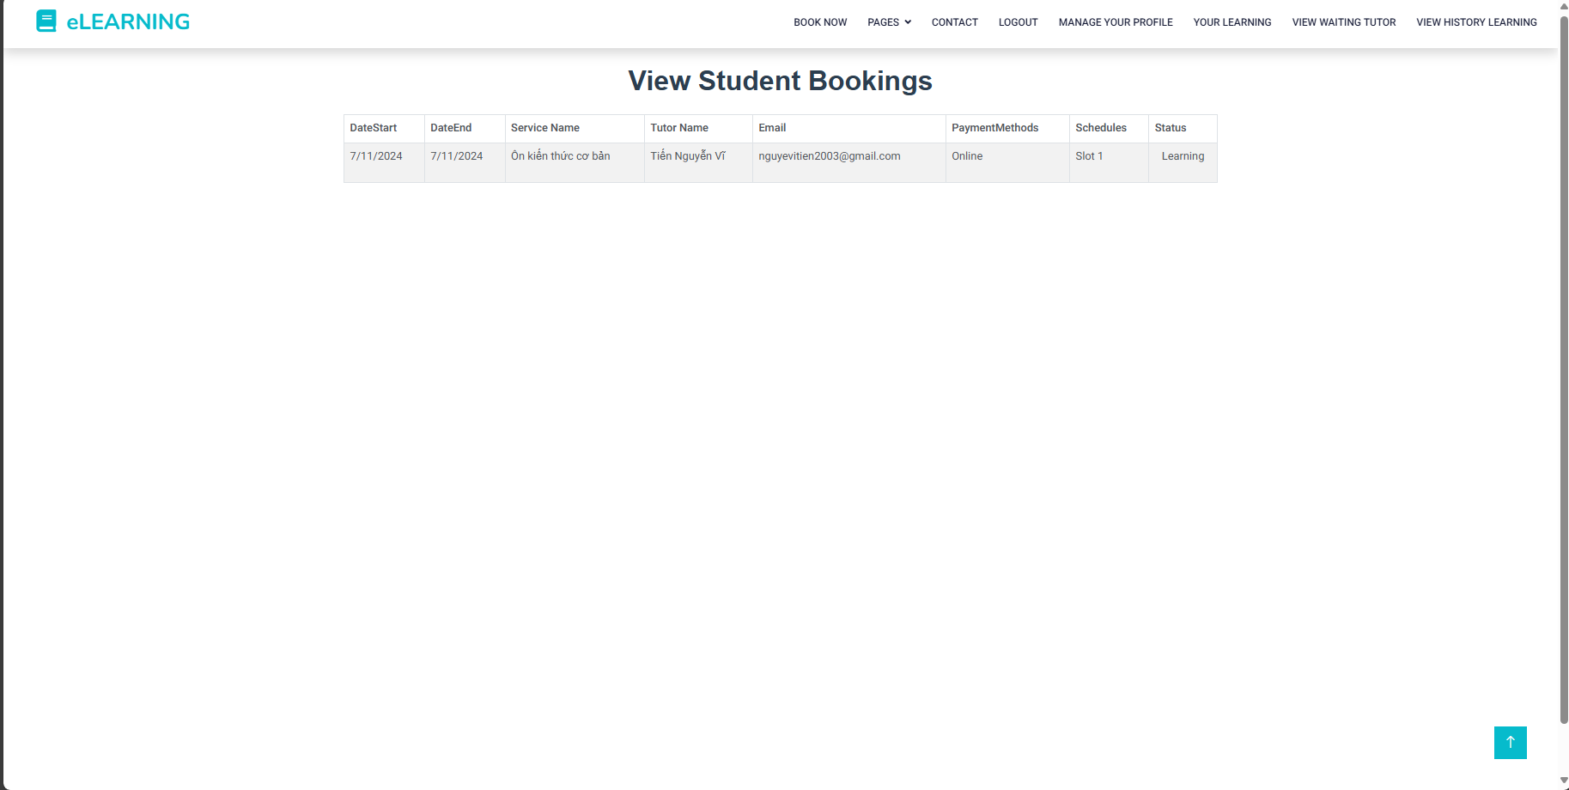

- The screen for students to view details of your service that you booked tutor.

4.2.2.8 View complete learning

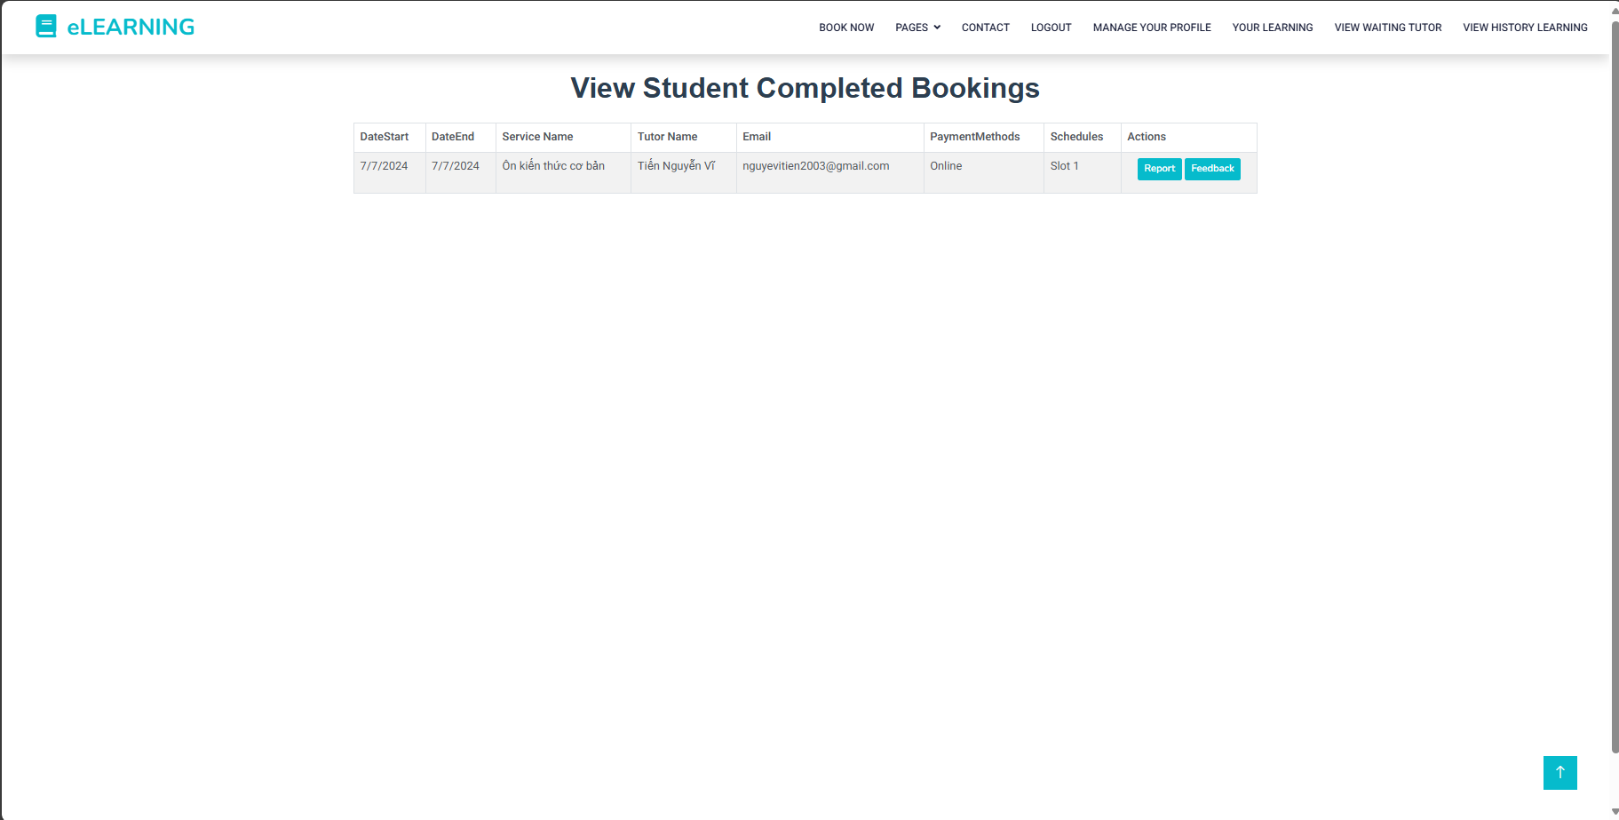

- The screen for students to view details of your service after they learned.

- Student can choose to give feedback or report about their experiences with the services by clicking on “Feedback” or “Report”button

4.2.2.8: Feedback

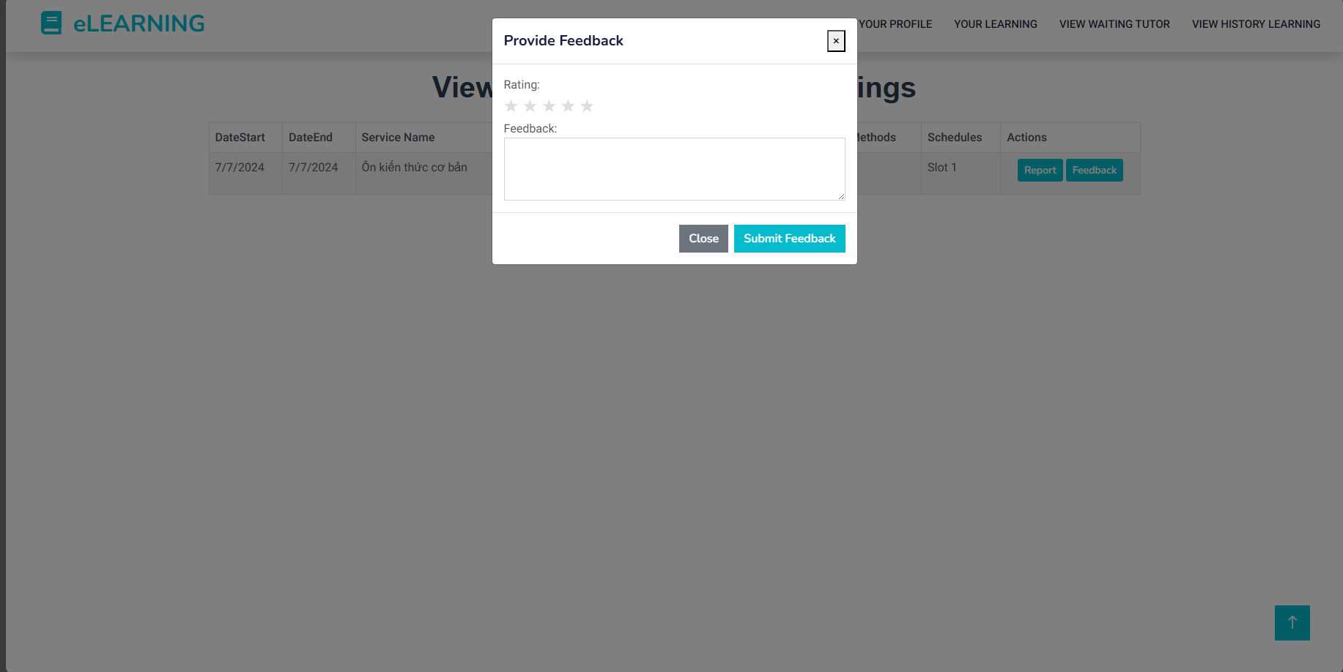

- Students can choose the star and give feedback for the service they learned.

4.2.2.9: Report

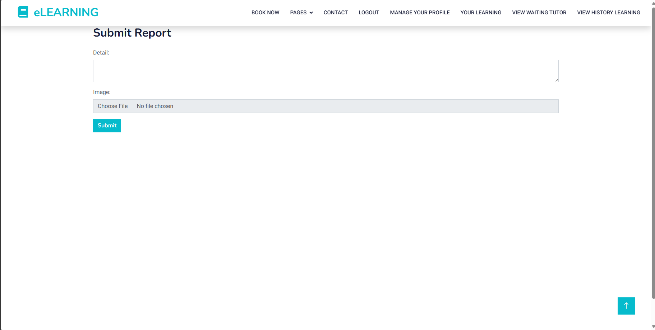

- Students can write a detailed report that they want to complain about and upload their picture to show evidence.

4.2.2.10

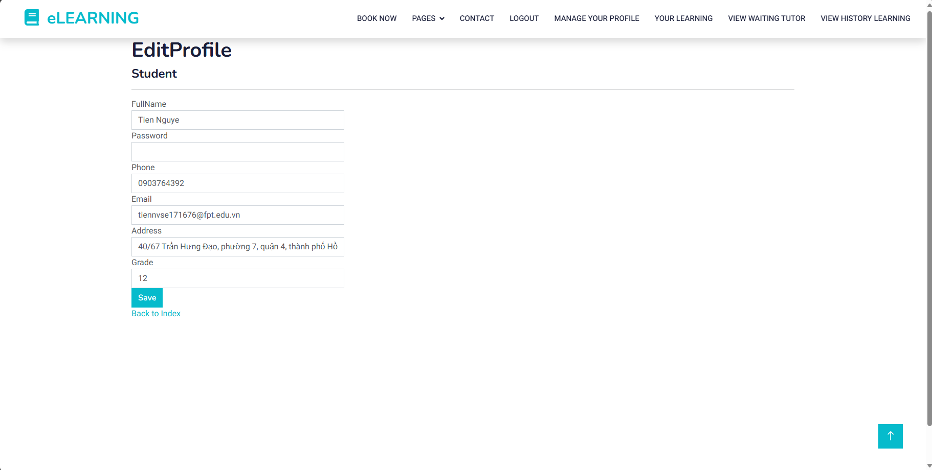

- The screen for students to view their profile

- Students can change their profile with fields:

* Full name field : required, cannot contain numbers or special characters
* Email field: required, valid email format
* Password field: required
* Grade field: required
* Address field: required

**TUTOR:**

4.2.2.11: View Tutor

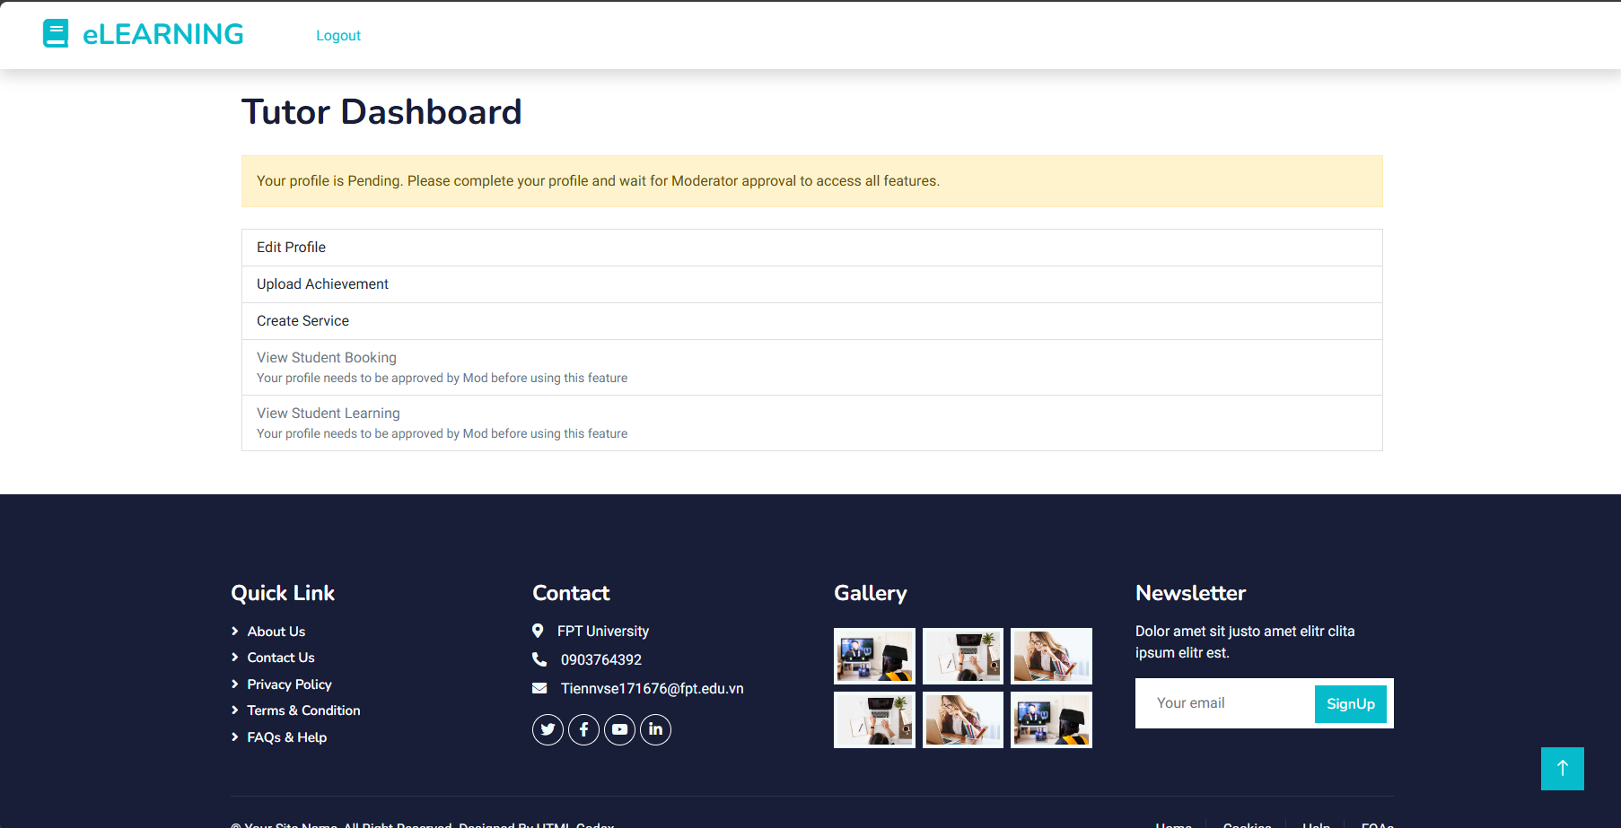

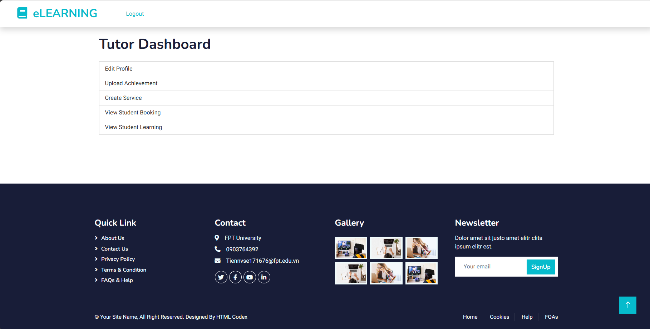

- The screen for the tutor to view their functions that they can use: Edit profile, Upload Achievements, Create Service, View Student Booking, View Student learning.

- If the tutor just registers an account they must to Edit profile, Upload Achievements, Create Service. After that tutor is waiting for the Moderator to check and accept your account.

- If the tutor has been accepted by the moderator and the student can book your service.

4.2.2.12 : Edit profile

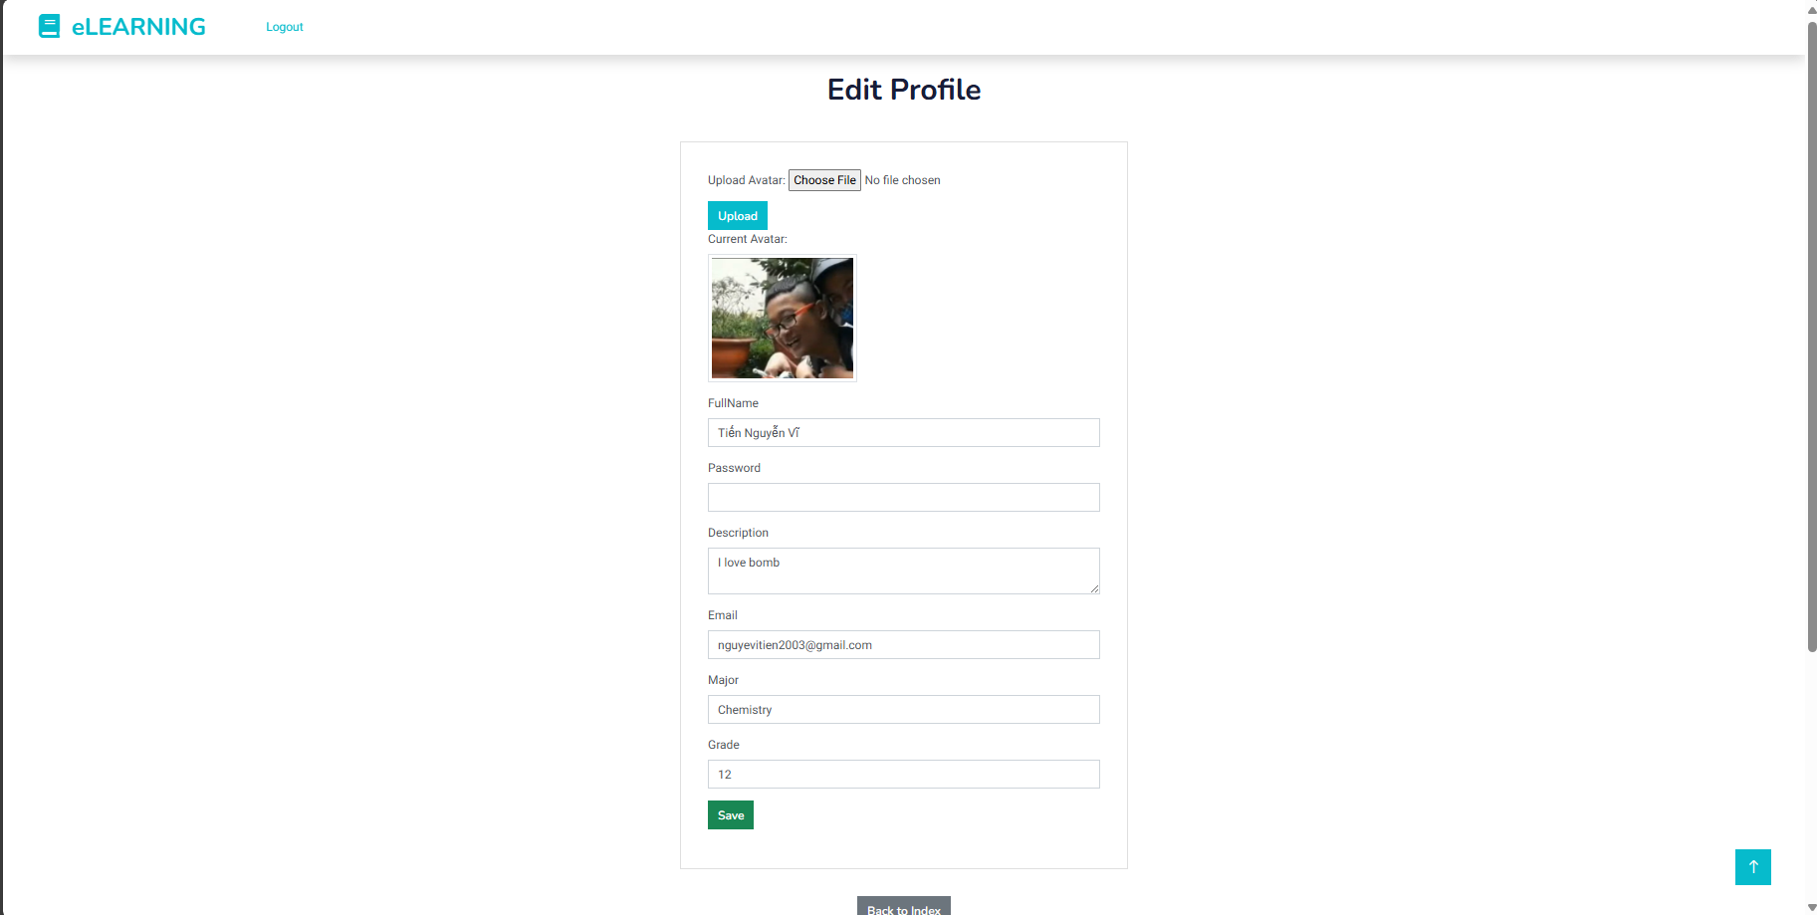

- The screen for tutor to view their profile.

- Tutor can change their profile with fields:

* Full name field : required, cannot contain numbers or special characters
* Email field: required, valid email format
* Password field: required
* Major: required
* Grade field: required
* Description field: required
* Upload tutor’s avatar

- After changing their profile, they must wait for the Moderator to check and accept their account.

4.2.2.13: Upload achievements

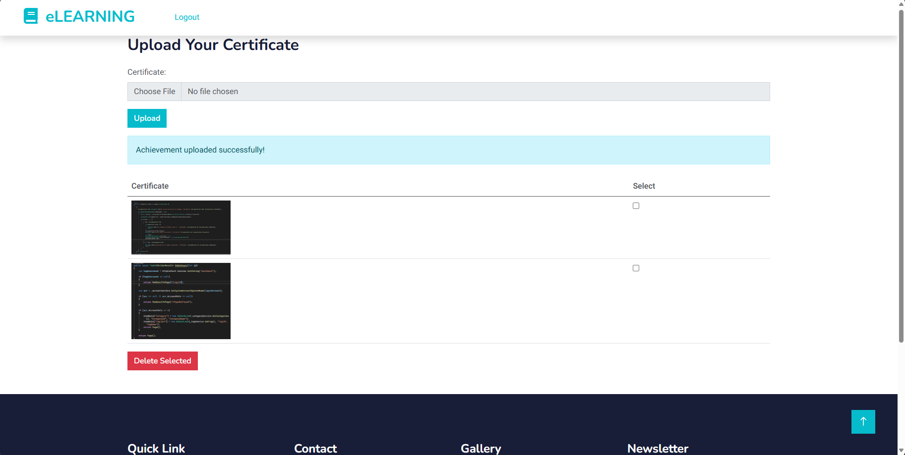

- The screen for the tutor to view their achievements.

- Tutors can upload their achievements when they want to show it to students.

- Tutors can tick the box next to their achievement and choose the “Delete” button to delete their achievement.

- After changing their achievement, they must wait for the Moderator to check and accept their account.

4.2.2.14: Choose price for service

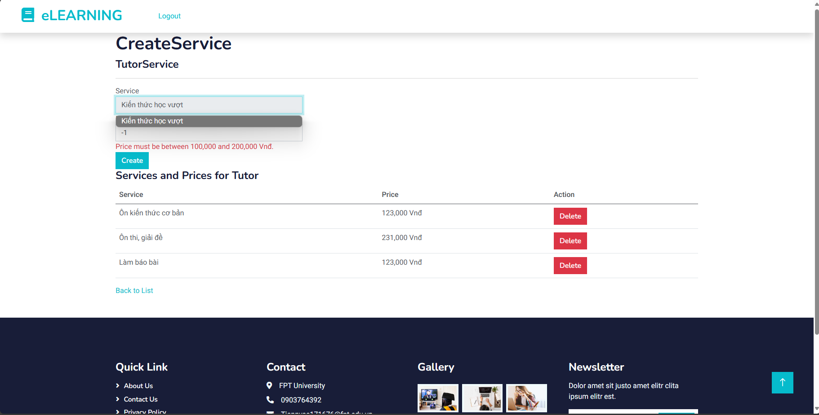

- The screen for the tutor to view their service’s price.

- Tutors can choose a price for their service when they want to show it to students.

- Tutors can tick the box next to their service and choose the “Delete” button to delete their service's price.

4.2.2.15 : List of booking tutor

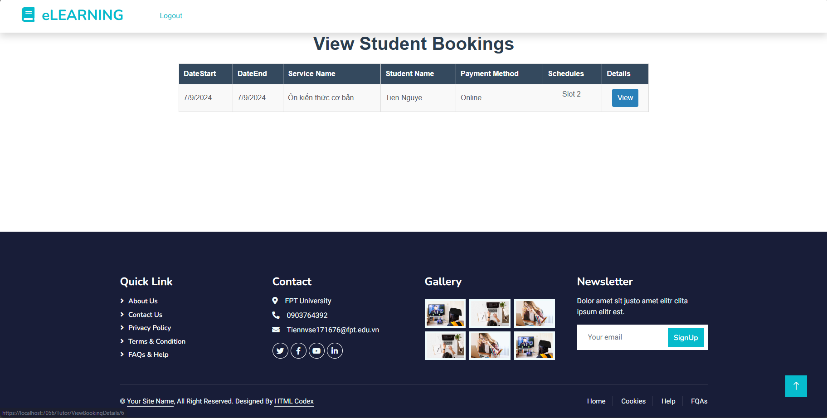

- The screen for the tutor to view the list of booking demand .

- Tutors can choose a price for their service when they want to show it to students.

- Tutors can tick the box next to their service and choose the “Delete” button to delete their service's price.

4.2.2.16: View detail booking’s student

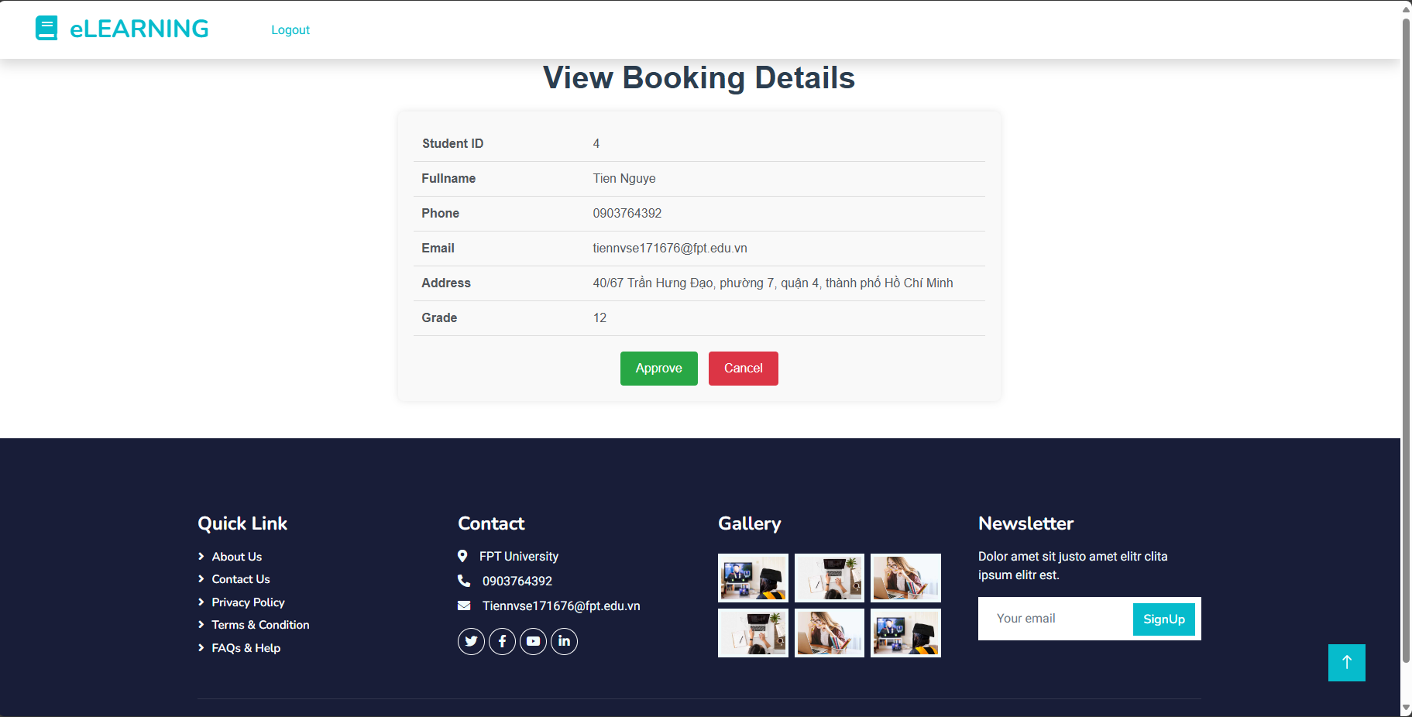

- The screen for the tutor to view the details of student booking.

- Tutors can choose the “Approve” or “Cancel” button for booking of students if they can’t available to teach.

4.2.2.17: View student learning

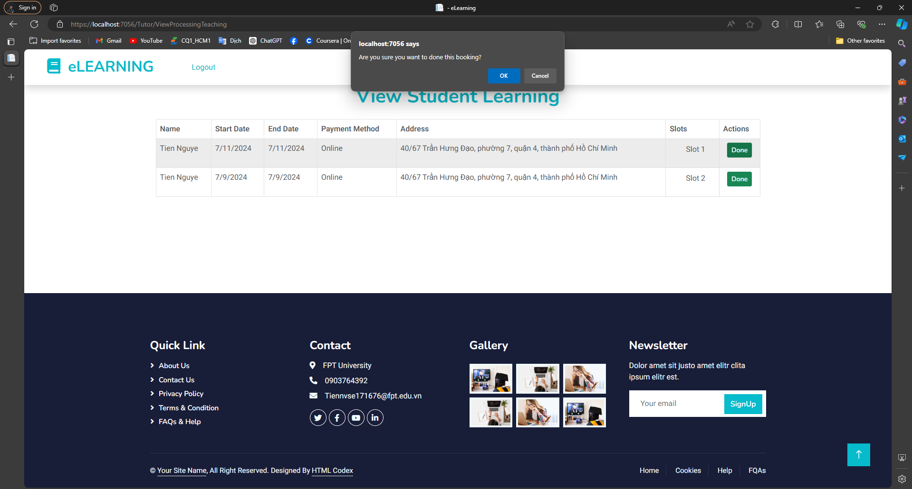

- The screen for the tutor to view the slot they have to teach students .

- Tutors can choose the “Done” when they finish the slot. And that slot will be finished.

- If the tutor didn’t choose the “Done” button, they would not have a salary.

**MODERATOR:**

4.2.2.18: View Moderator

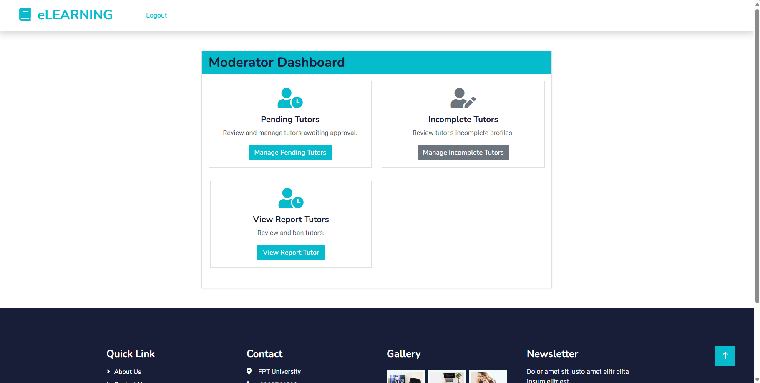

- The screen for the moderator to view their functions that they can use:. Manage Pending Tutors, Incomplete Tutors, View Report Tutors.

4.2.2.19: Pending tutors

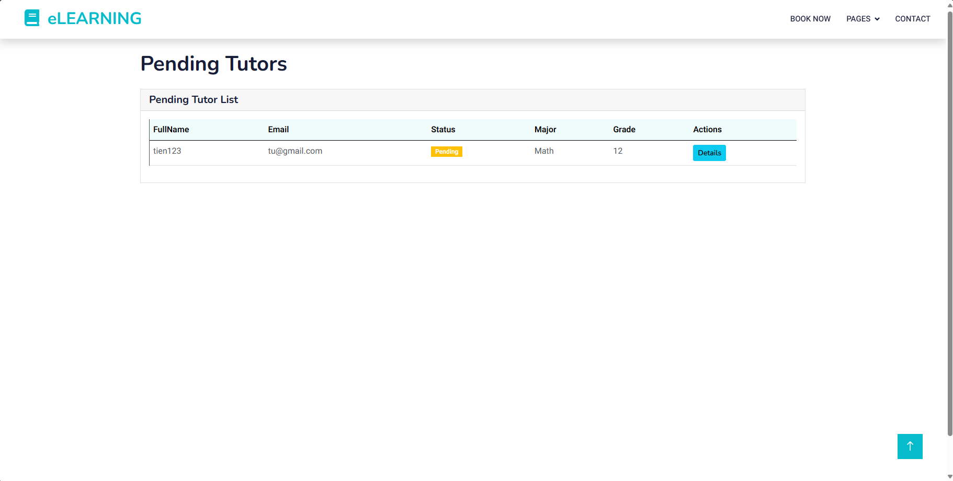

- The screen for the moderator to view a list of Tutors with status Pending need to accept to Active, that will be allowed Tutor can book by Students.

- The moderator can choose the “Detail” button to see more details about the tutors.

4.2.2.20: Tutor details

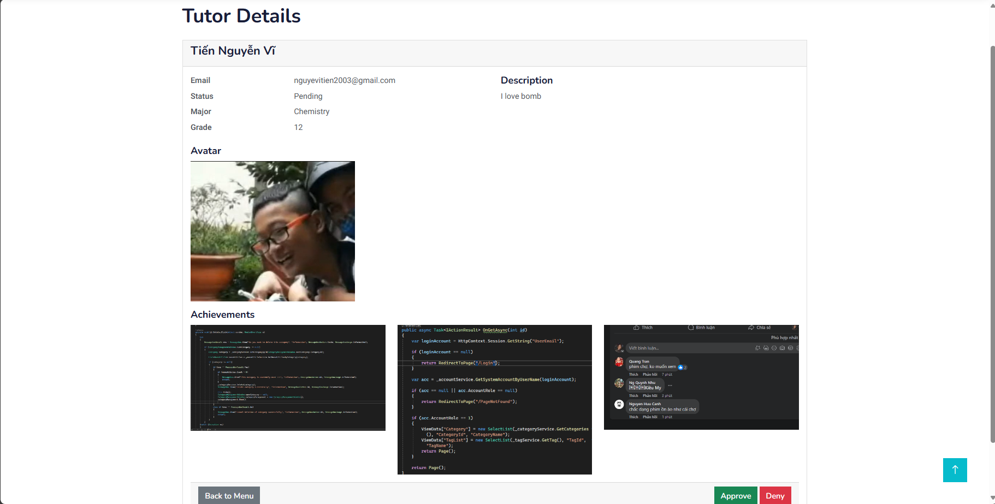

- The screen for the moderator to view the details of Tutors with fields:

* Email
* Major
* Grade
* Description
* Avatar
* Achievements

- The moderator can choose the “Approve” button if the tutor has all fields.

- The moderator can choose the “Deny” button if the tutors don’t have enough fields to see more details about the tutors, and status will change to Incomplete, tutor that must be filled again.

4.2.2.21: Incomplete Tutors

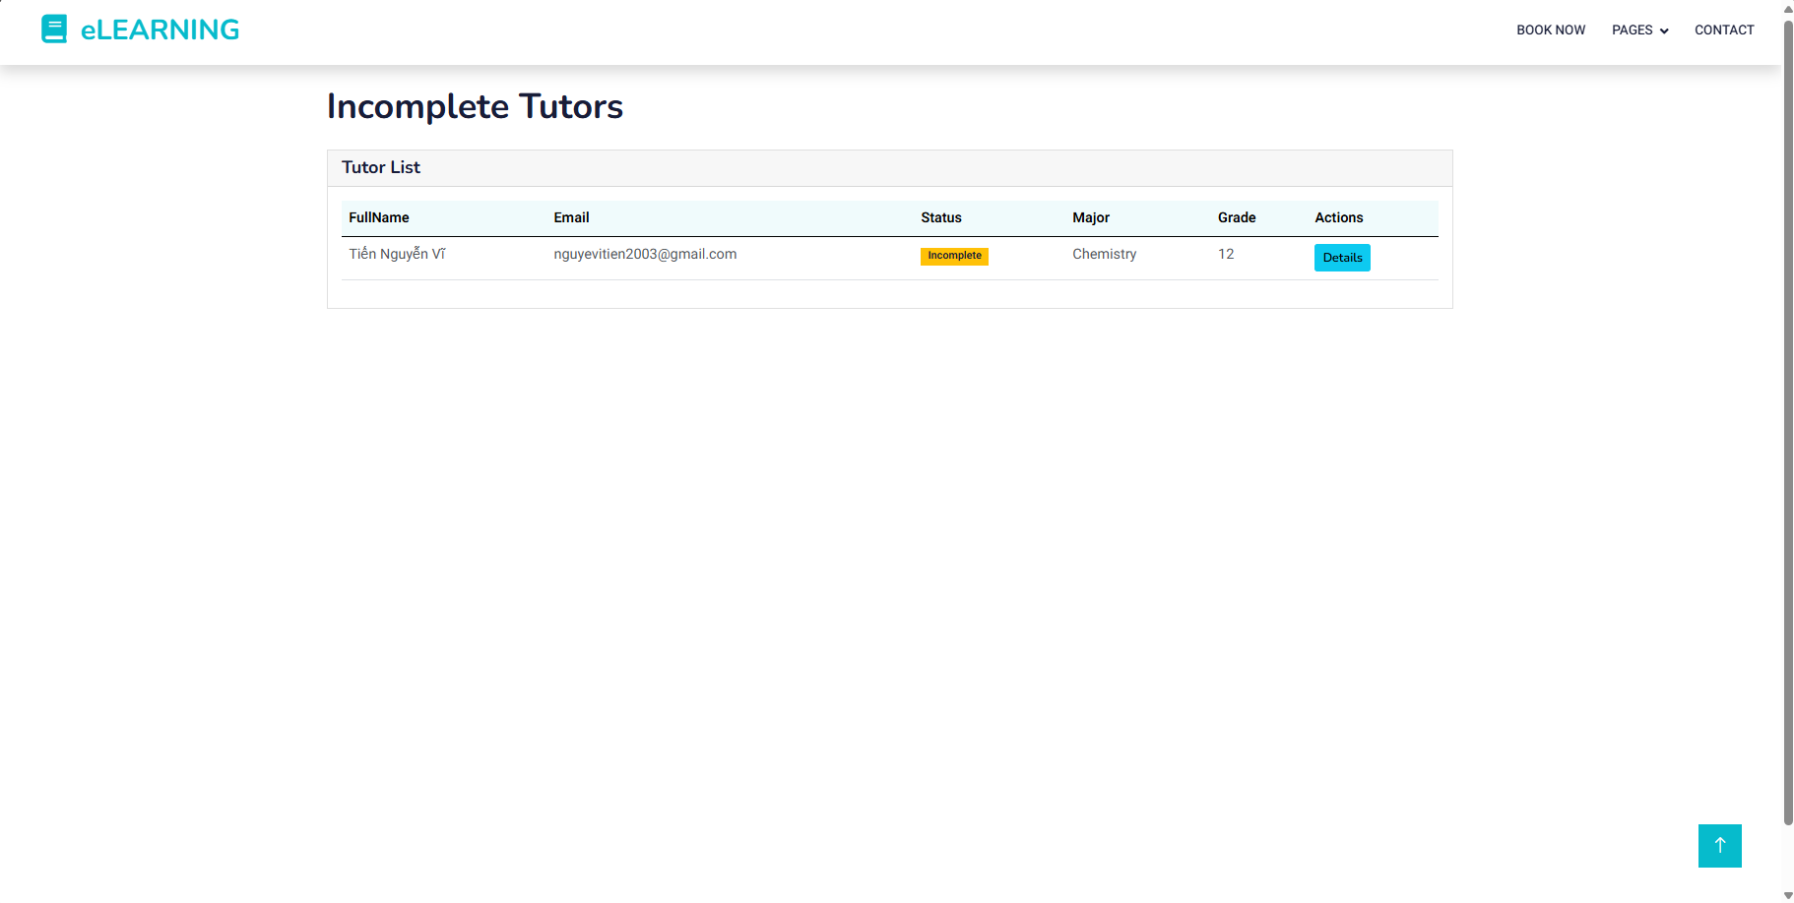

- The screen for the moderator to view a list of Tutors with status Incomplete because they have been denied by the moderator.

- The moderator can choose the “Detail” button to see more details about the tutors.

4.2.2.22: Incomplete tutor details:

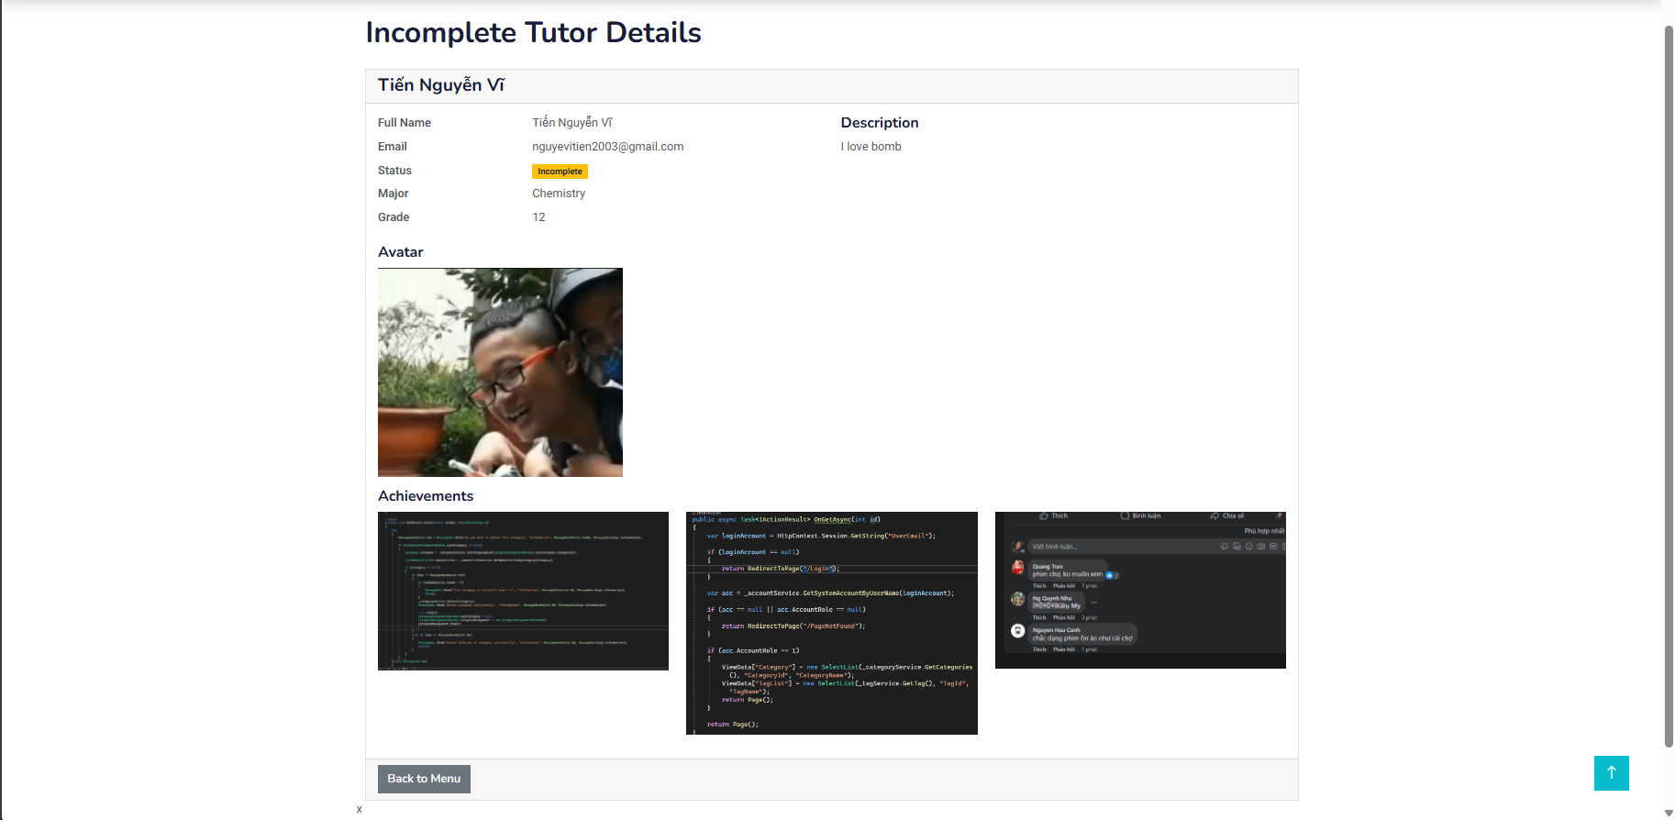

- The screen for the moderator to view the details of Tutors with fields:

* Email
* Major
* Grade
* Description
* Avatar
* Achievements

4.2.2.23: View report

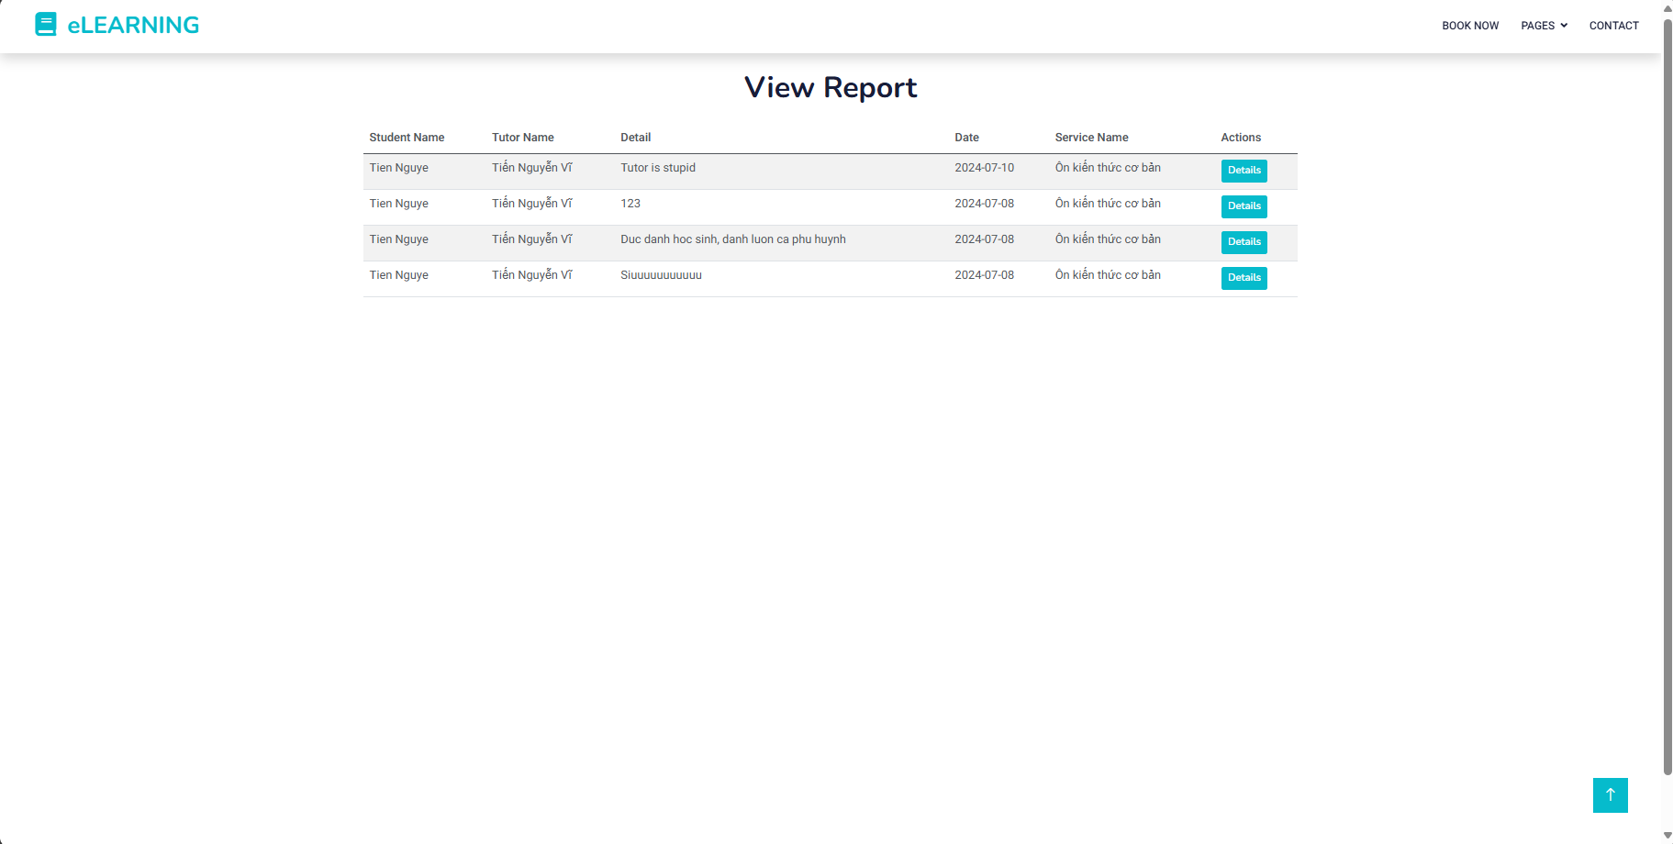

- The screen for the moderator to view a list of reports of students to tutor.

- The moderator can choose the “Detail” button to see more details about the report.

4.2.2.24: View detail report:

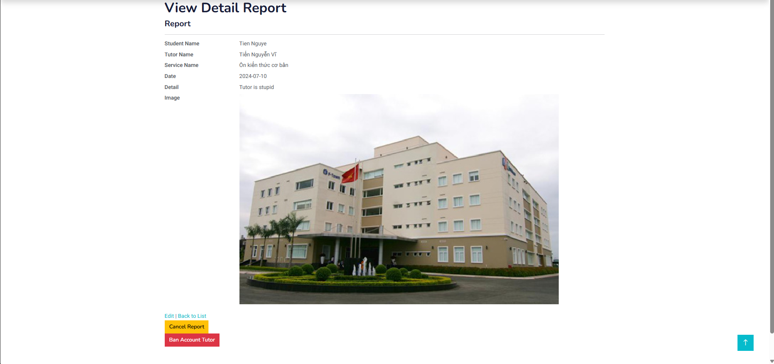

- The screen for the moderator to view a list of reports of students to tutor with name’s tutor, service name, date, description report about tutor and image about evidence.

- The moderator can choose the “Cancel” button to deny the report if the moderator sees that it is not true.

- The moderator can choose the “Ban Account Tutor” button to deny the report if the moderator sees that it is true.

**ADMIN:**

.4.2.2.25: View Admin

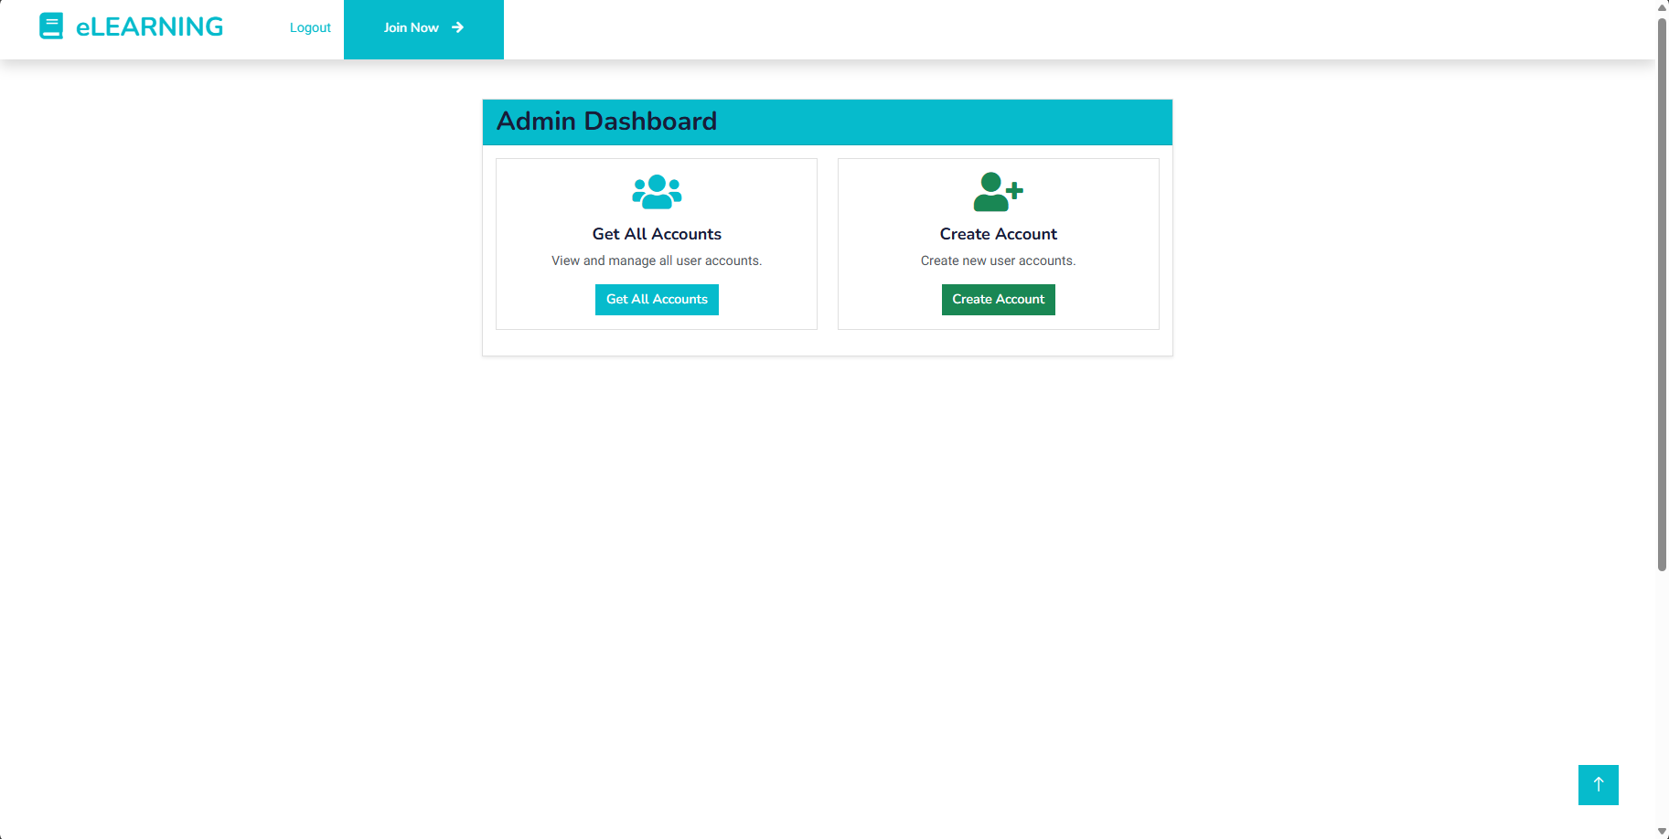

- The screen for the admin to view their functions that they can use: Get All Accounts, Create Account for mod.

4.2.2.26: Get all account

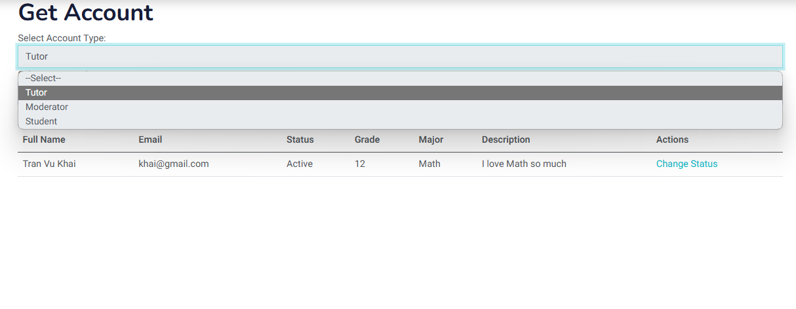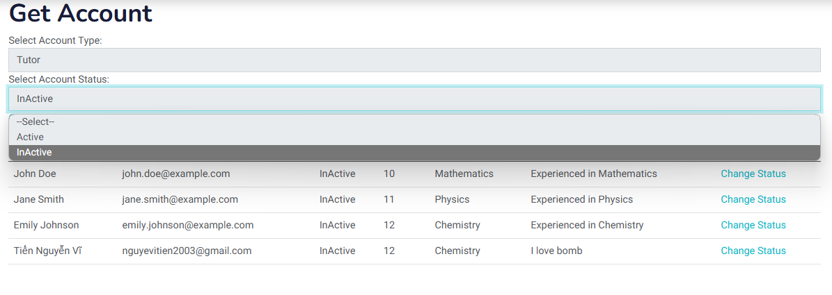

- The screen for the admin to view all account with 2 filter:

* Account: Student, Tutor, Moderator
* Status: Active, InActive

- The admin can choose the “Change Status” button to change status from Active to InActive or InActive to Active.

4.2.2.27: Change Status

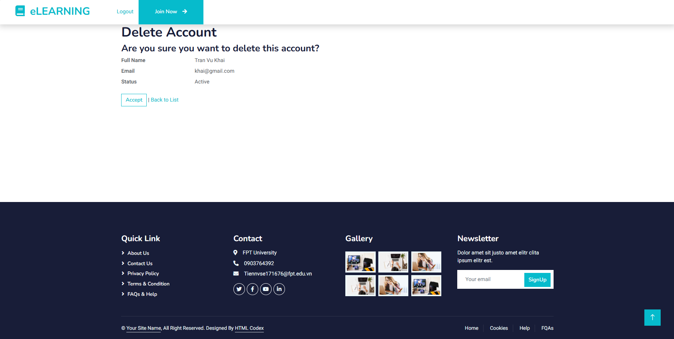

- The screen for the admin to view an account with Full name, Email, Status.

- The admin must choose the “Accept” button to confirm that they want to change status from Active to InActive or InActive to Active.

4.2.2.28: Create Account Moderator

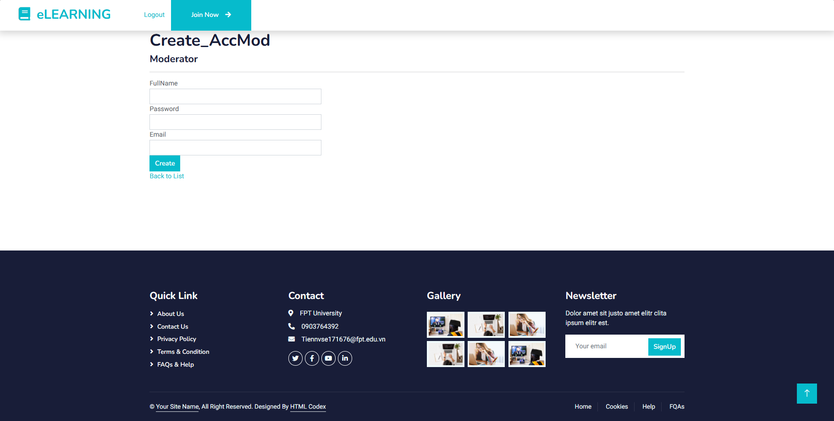

- This screen is for admin register for moderator for using more features including requirements:

* Full name field : required, cannot contain numbers or special characters
* Email field: required, valid email format
* Password field: required

4.2.2.29: Admin dashboard statistics

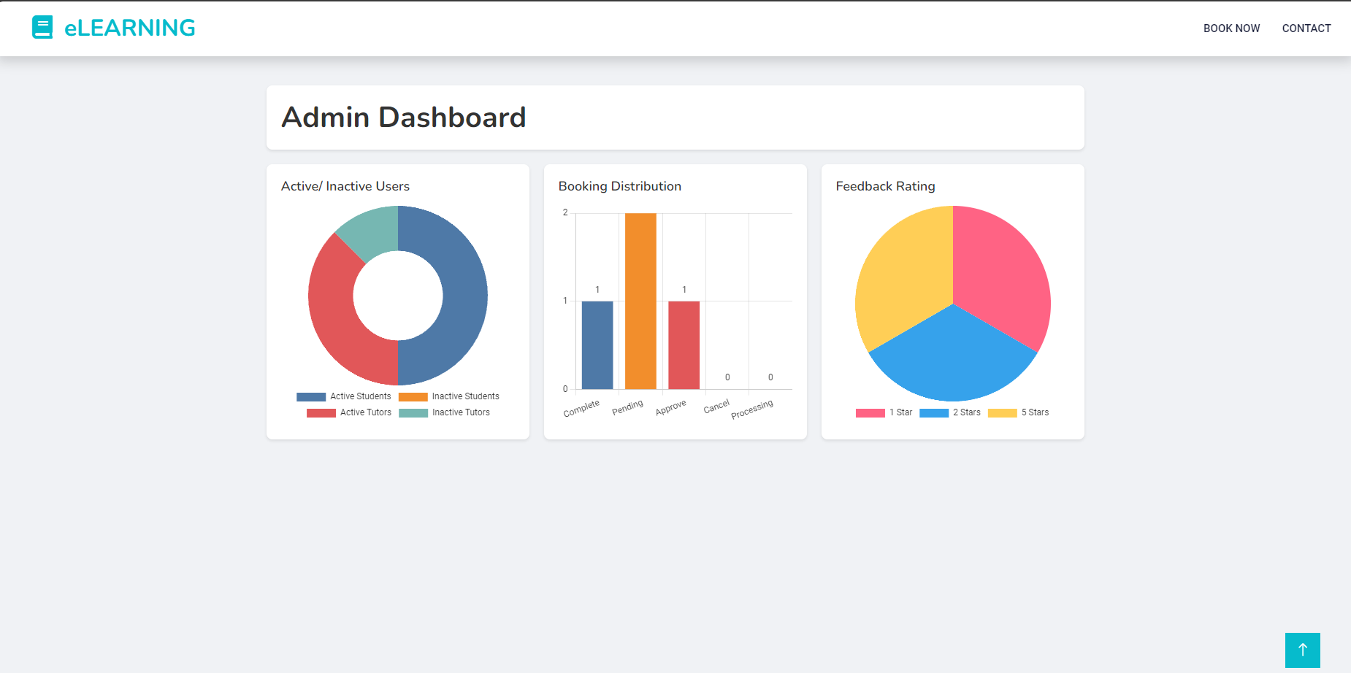

- This screen is for admin to see statistic charts to analyze system:

* Doughnut chart : View the quantity of Active or Inactive User of the system
* Bar chart: View the quantity of the distribution of bookings
* Pie chart: View the percentage distribution of rating in feedbacks

5. References

1. [*www.free-css.com*](http://www.free-css.com) *website, ELEARNING FREE CSS TEMPLATE.* [*eLEARNING Free Website Template*](https://www.free-css.com/free-css-templates/page291/elearning)